Regular Programme

Regular NSS programmes are those programmes under which students undertaken various activities in adopted villages, College campuses and Urban Slums during weekends or after college hours.

Students have to work for at least 120 hours a year in social service projects.

Students can work in small groups or individually.

Many different activities could be taken by different groups of students studying in the same educational institution at different times of the day.

The activities undertaken as regular programmes can be social service in institutions like Hospitals, Schools, work in institutions for handicapped, etc. work can also be done without an agency structure, campaign, socio-economic projects, or follow-up of activities initiated during the special camps.

Objective of Regular Programme

To create as awareness about the problems and life style of the community.

To help realize the dignity of labour.

To provide experience of working together.

To inculcate leadership qualities.

To develop a sense of responsibility and

To build a strong character

Areas of Regular Programme

College campus.

Adopted Village/Urban Slum.

Welfare institutions. (Old age homes, orphanages, challenged homes)

Hospitals.

Any others. (Eco Concerns, Road Safety etc.)

Massive Tree plantation program - “ONE STUDENT ONE TREE”

The Honourable Chancellor and Governor of TamilNadu have initiated a massive tree plantation programme in the main campus of Anna University.
In continuation of the advice of Honourable Governor, NSS of Anna University has adopted the concept of “One Student One Tree”. Anna University including main campus , constituent college and affiliated colleges have planted the total saplings of more than 3,00,000.
All the trees are well maintained by providing drip irrigation system and all the trees have well grown.
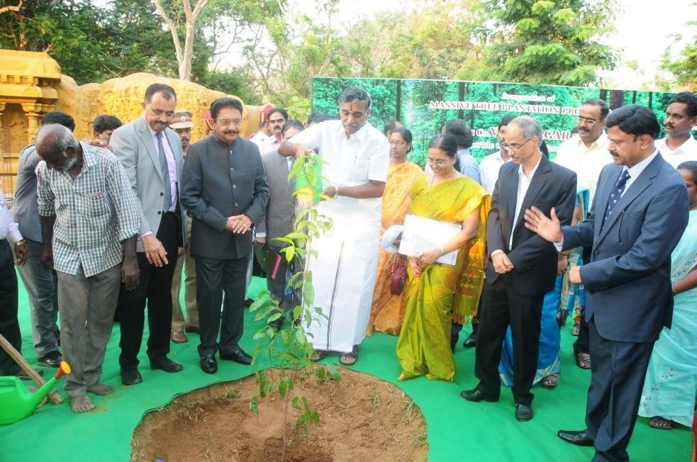

Honourable Governor of Tamil Nadu and Minister for Higher Education initiated a massive tree plantation programme in the main campus of Anna University

TREE PLANTATION
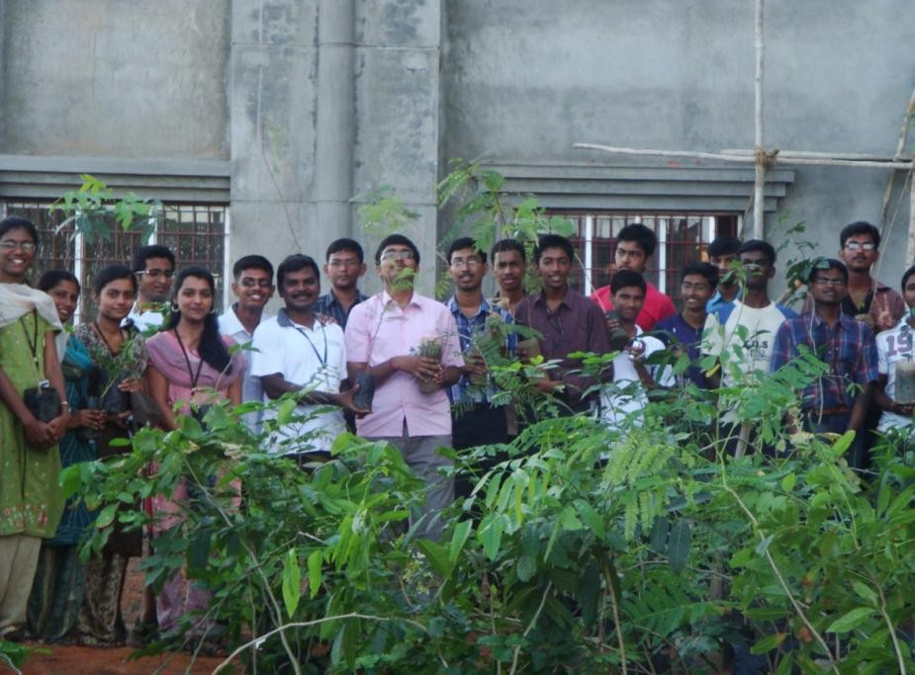
TREE PLANTATION IN ADOPTED VILLAGE

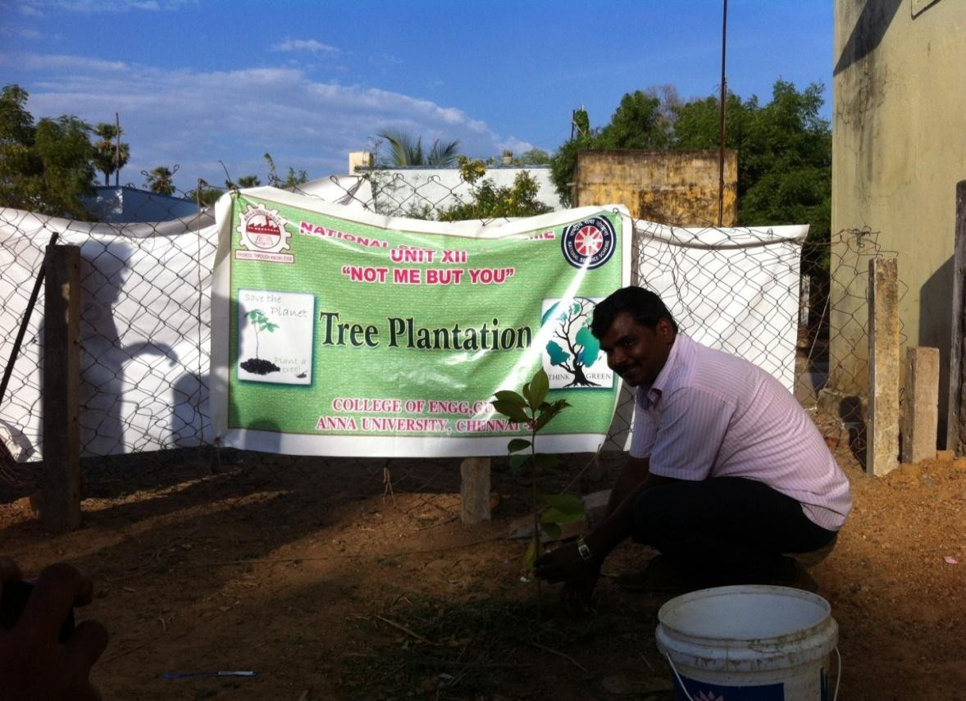

INDEPENDANCE DAY CELEBRATION IN OUR COLLEGE
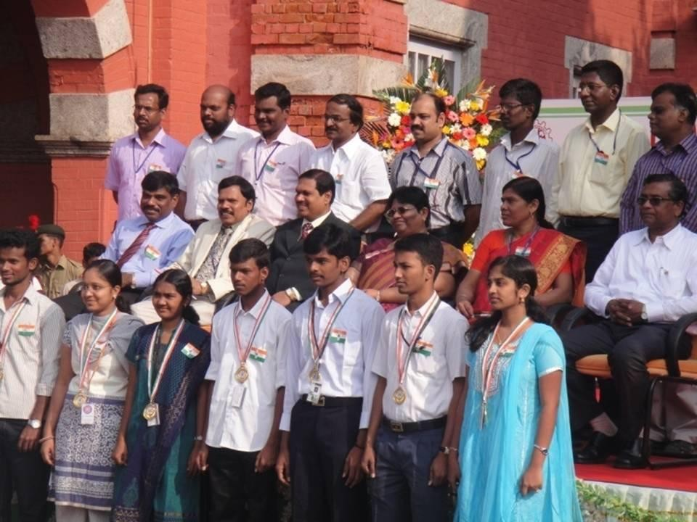

BEACH CLEANING INAUGURATED BY CHENNAI MAYOR
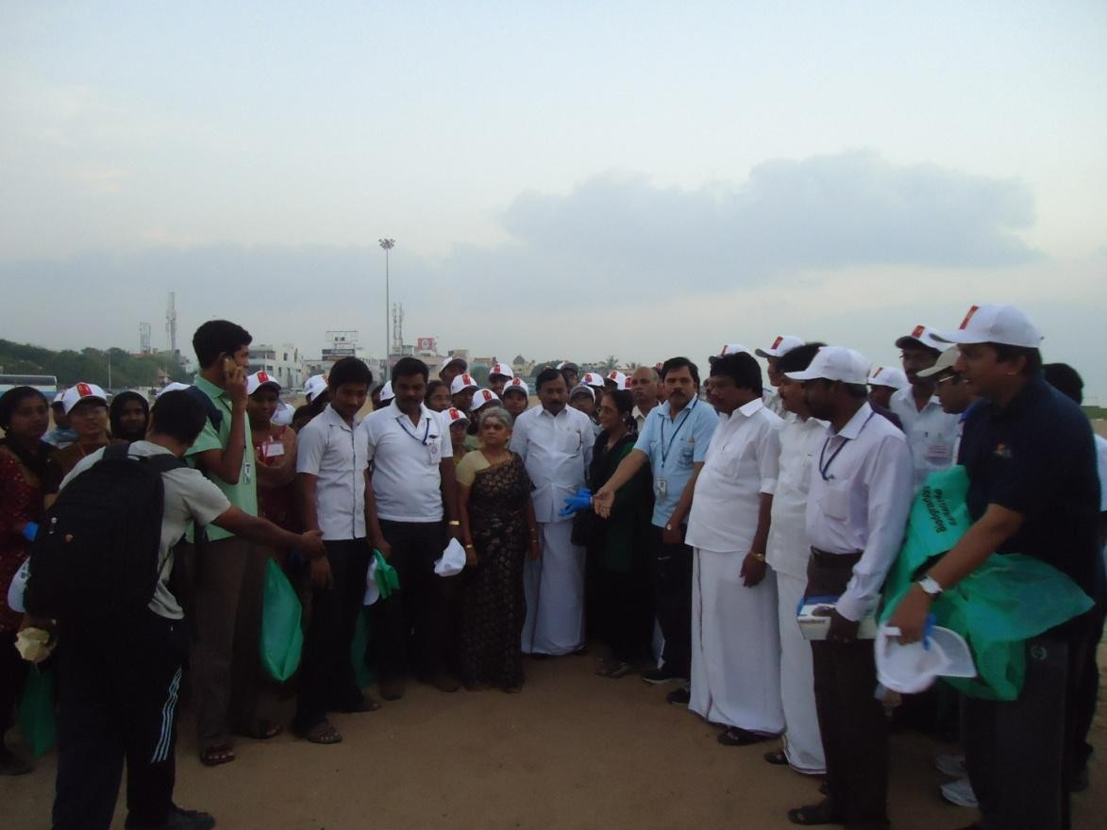

SWACHH BHARAT ABHIYAN
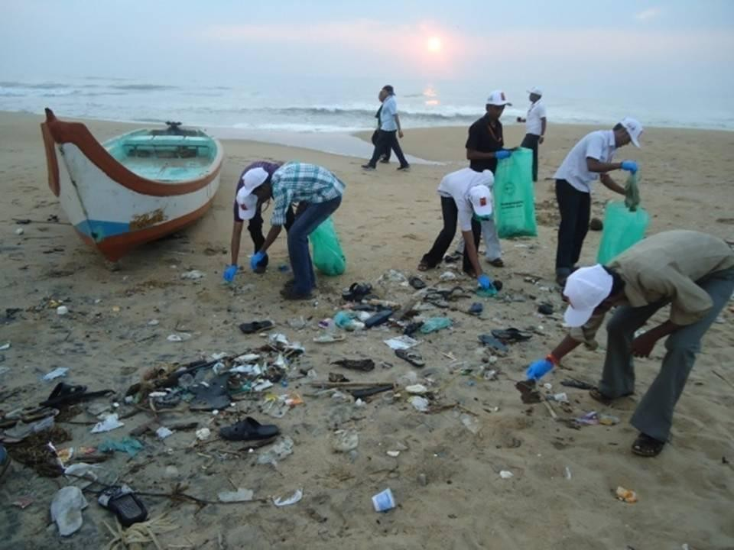

SWACHH BHARAT ABHIYAN
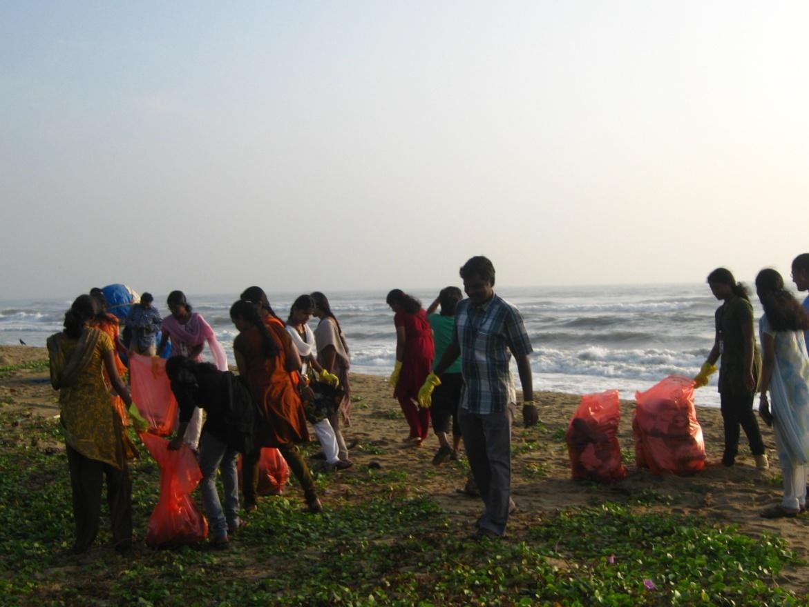

SWACHH BHARAT ABHIYAN
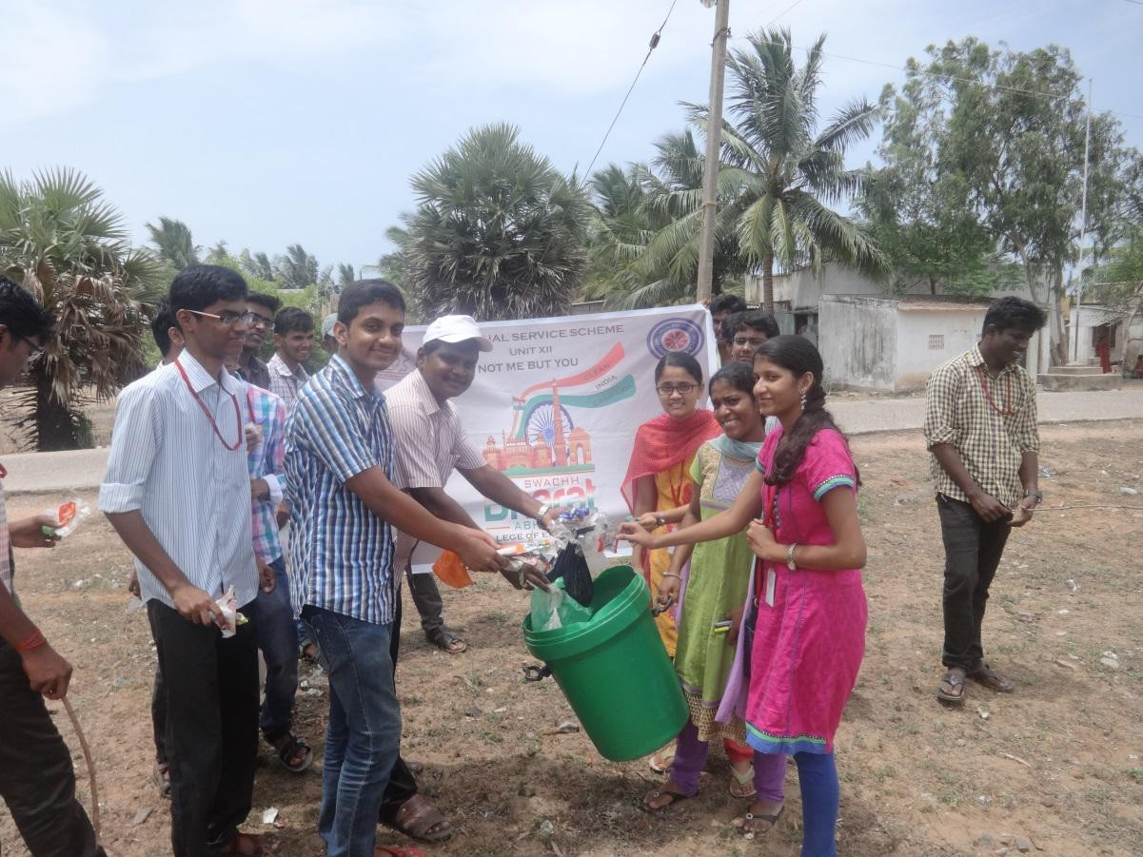

SWACHH BHARAT ABHIYAN
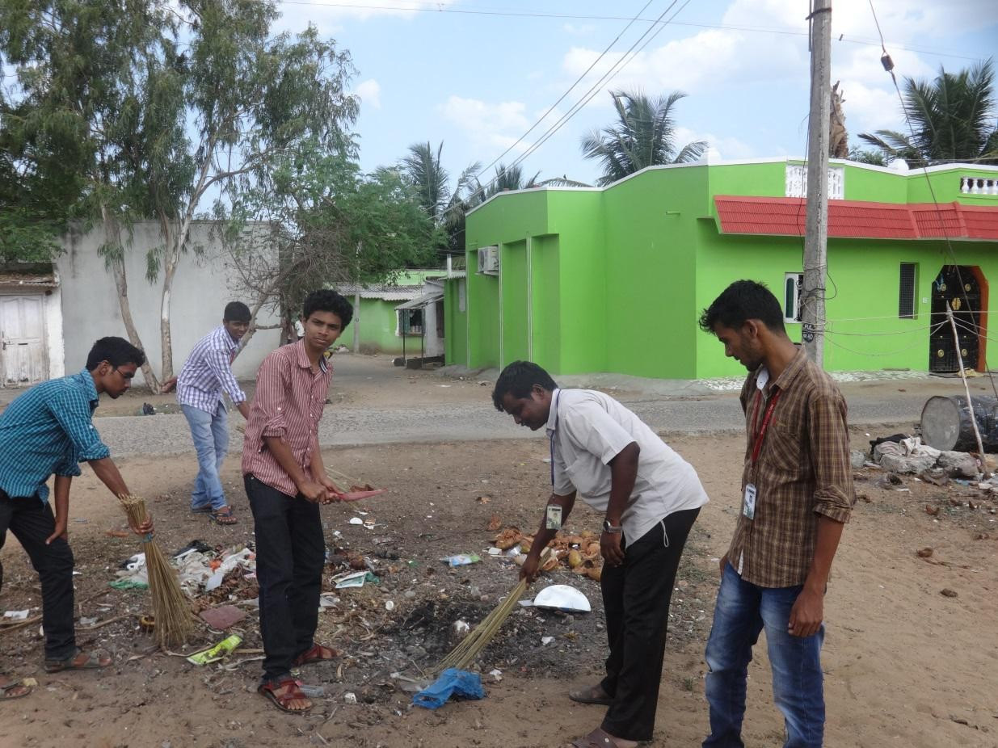

SWACHH BHARAT ABHIYAN
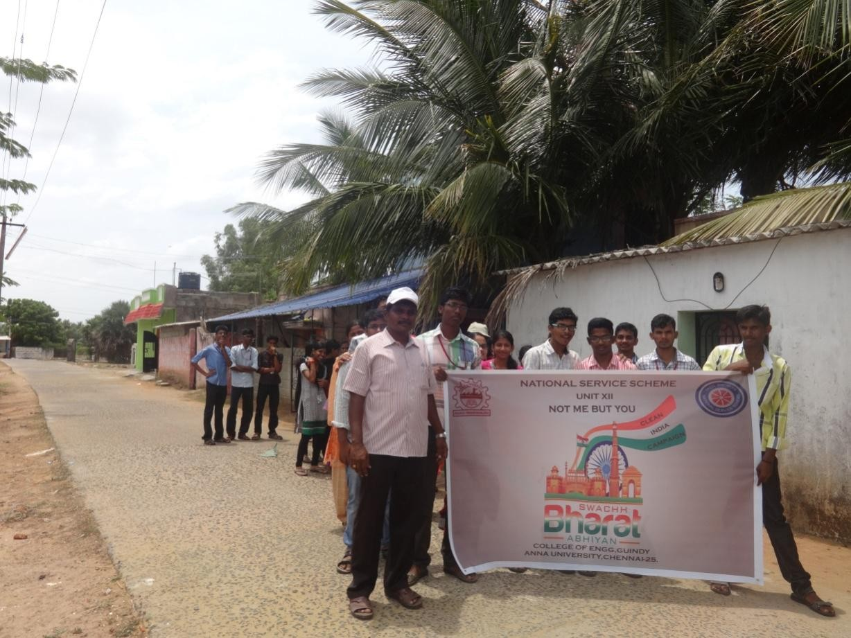
NON BIO DEGRADABLE MATERIALS COLLLECTED FROM THE BEACH
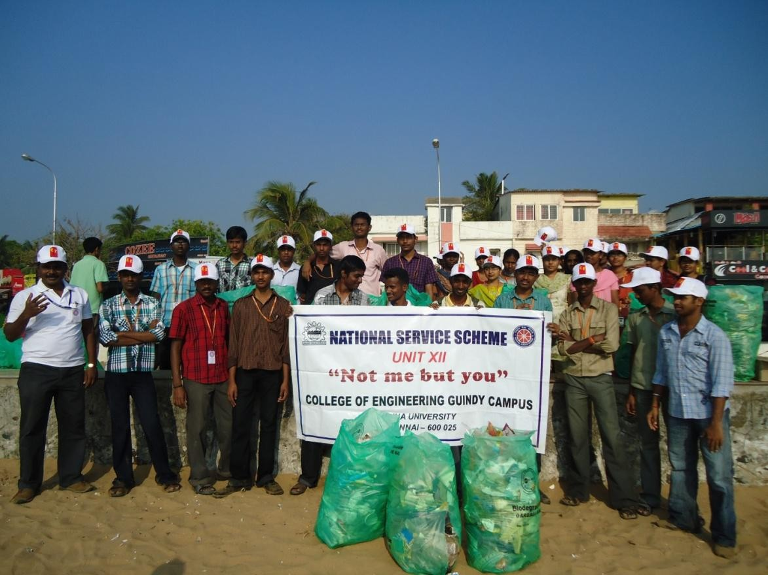

NON BIO DEGRADABLE MATERIALS COLLLECTED FROM THE BEACH
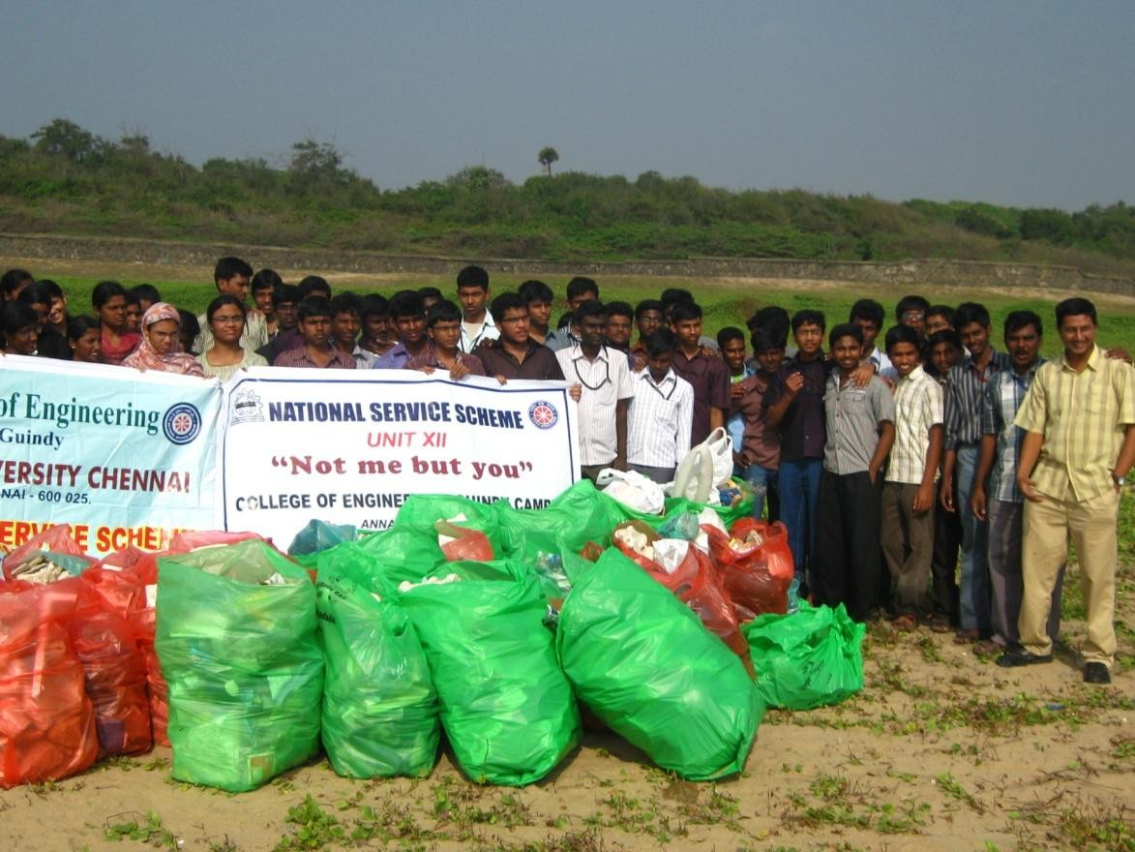
A TALK WITH VOLUNTEERS BY PROGRAMME OFFICER
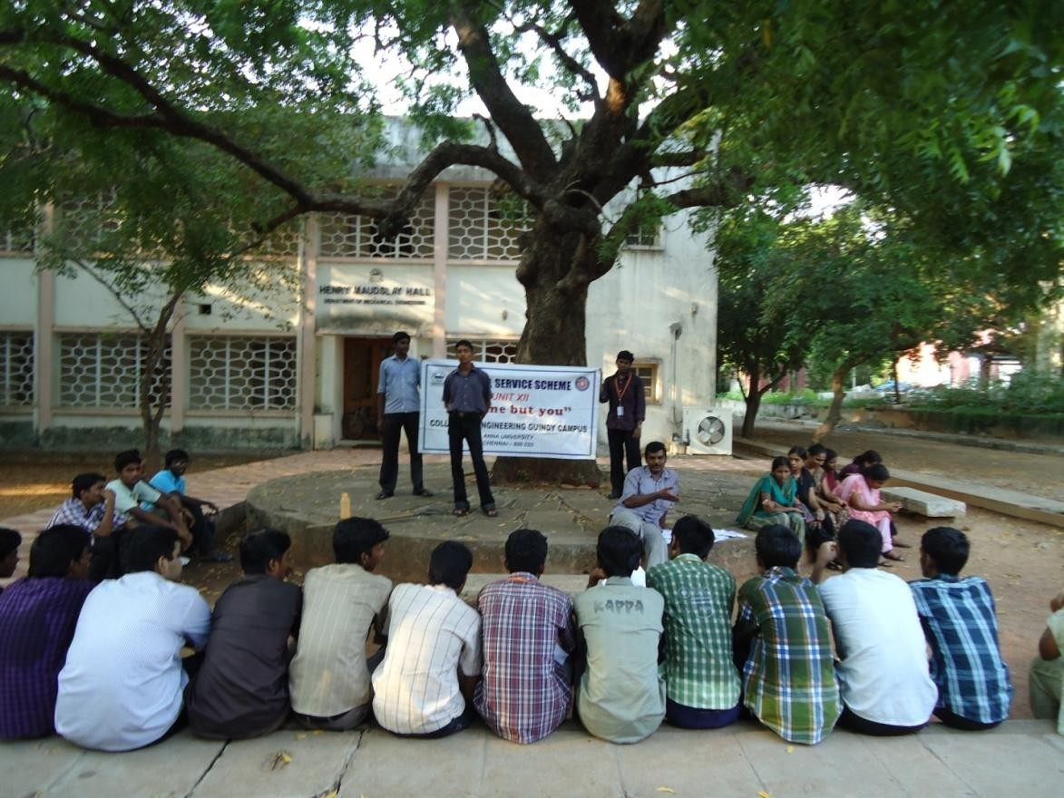

ROAD SAFETY AWARENESS PROGRAMME
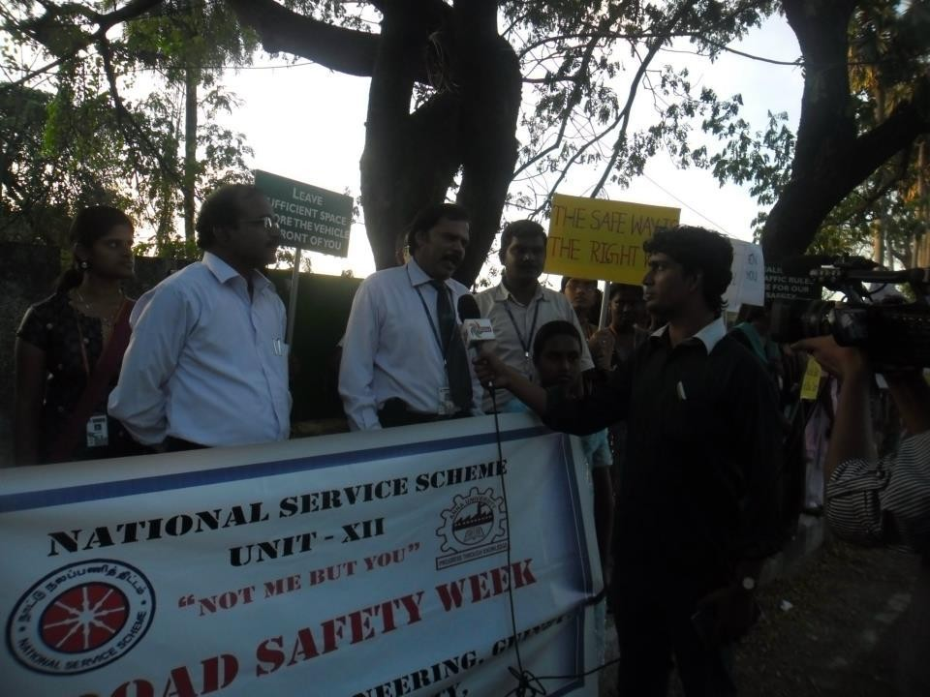

ROAD SAFETY AWARENESS PROGRAMME
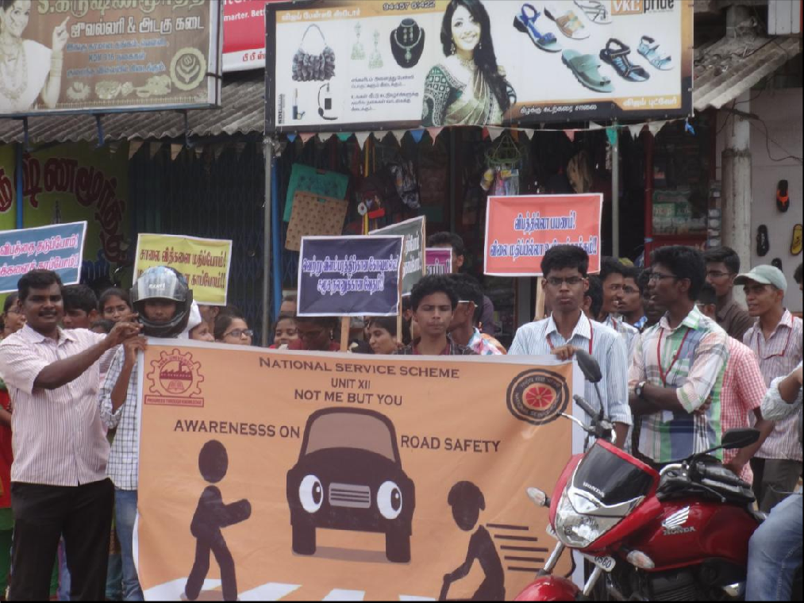

CELEBRATING GANDHIJI’S BIRTHDAY IN OUR COLLEGE
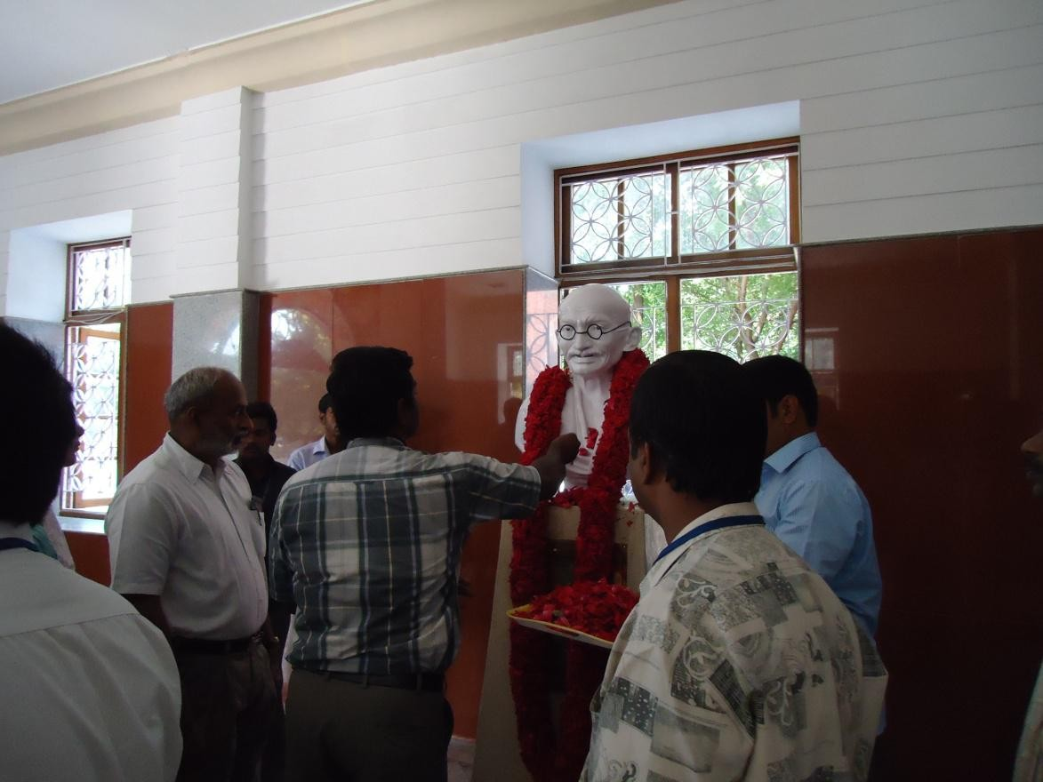

CELEBRATING NATIONAL DAY FOR THE MENTALLY RETARDED PERSONS
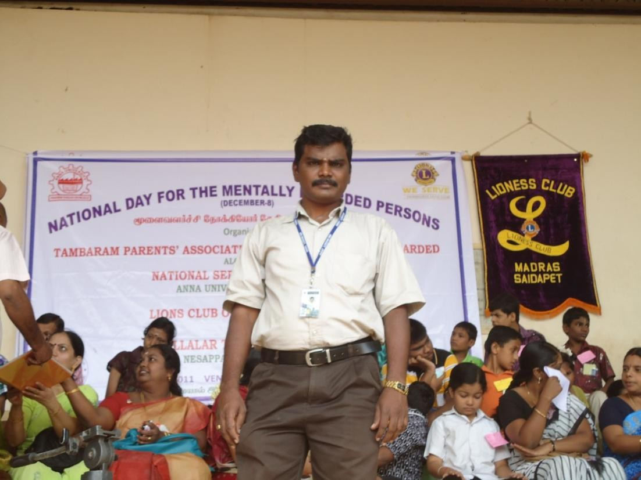

PROVIDING FOOD TO THE MENTALLY RETARDED PERSONS
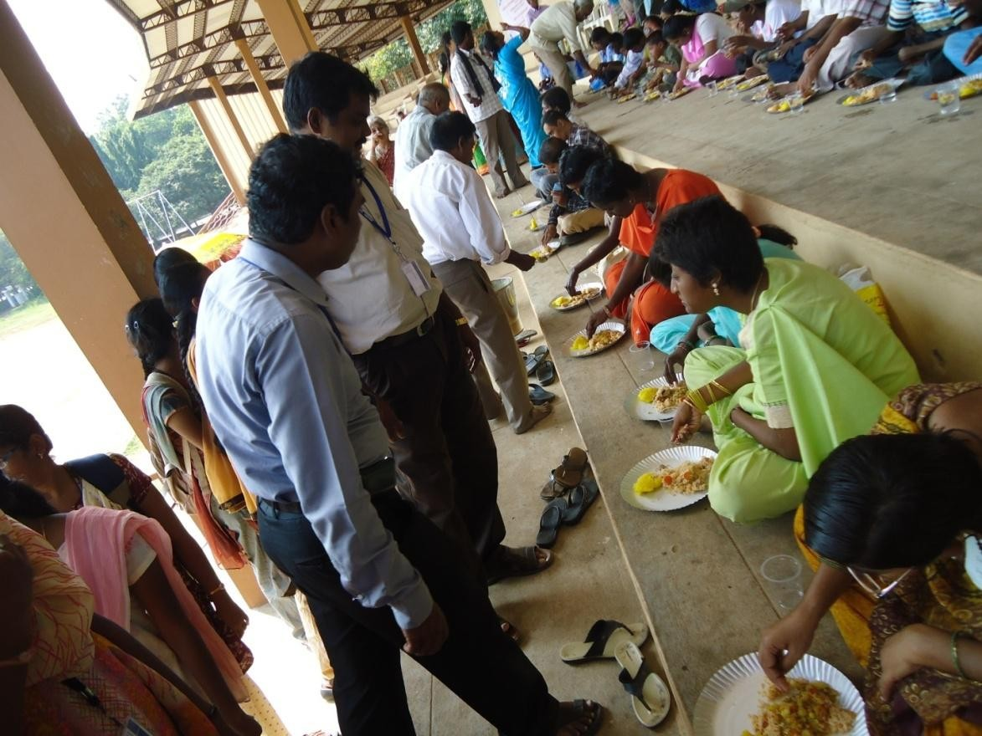
BLOOD DONATION CAMP
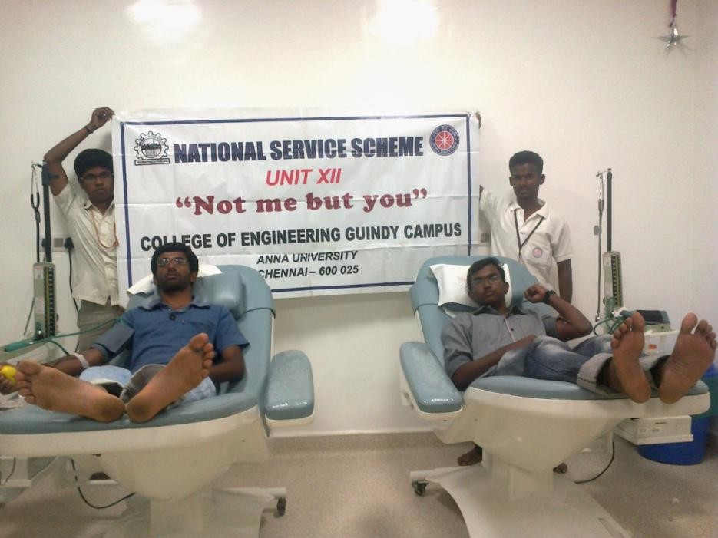

FREE EYE CAMP IN THE ADOPTED VILLAGE
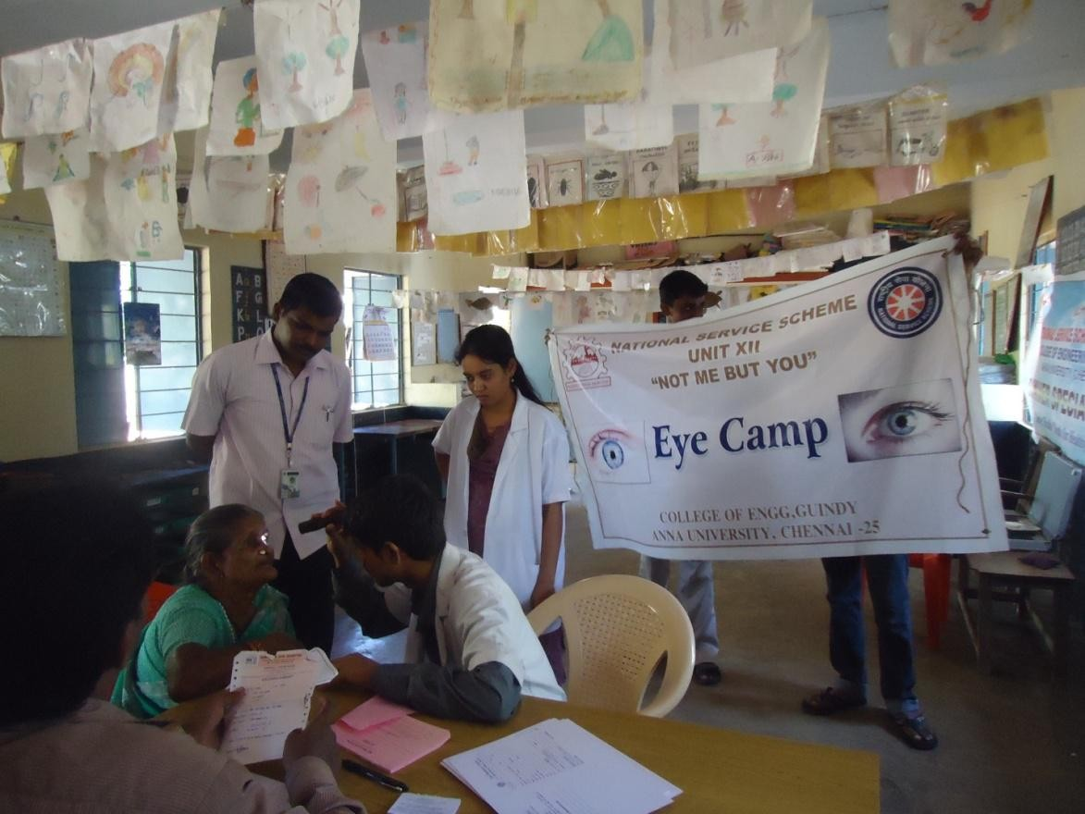

AWARENESS ON SAFE DIWALI CELEBRATED IN OUR COLLEGE
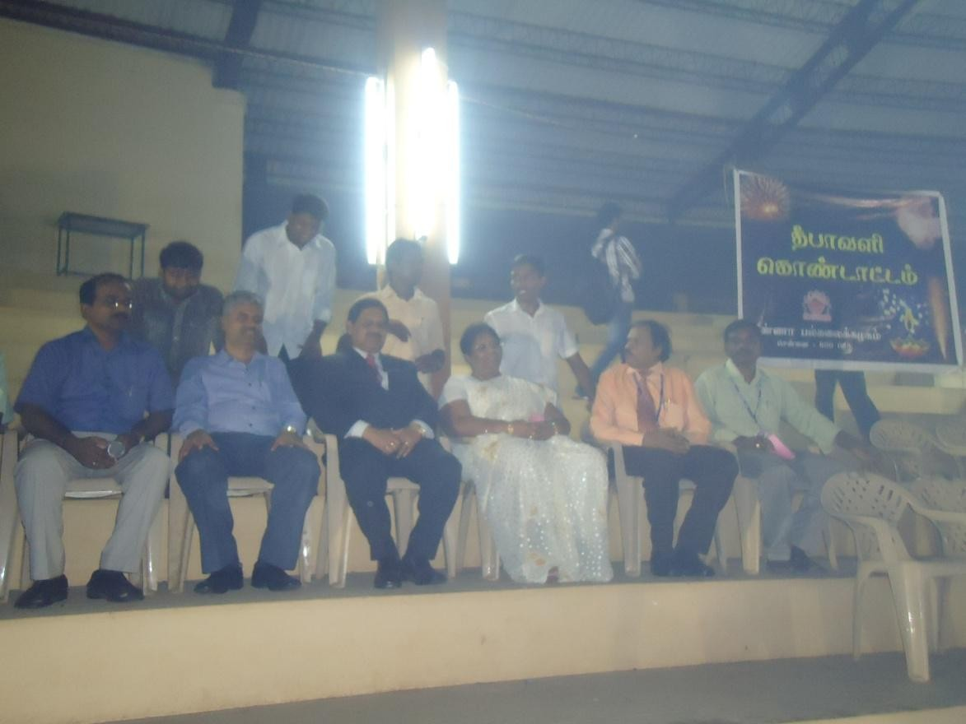

AWARENESS ON RENEWABLE ENERGY BY TEDA
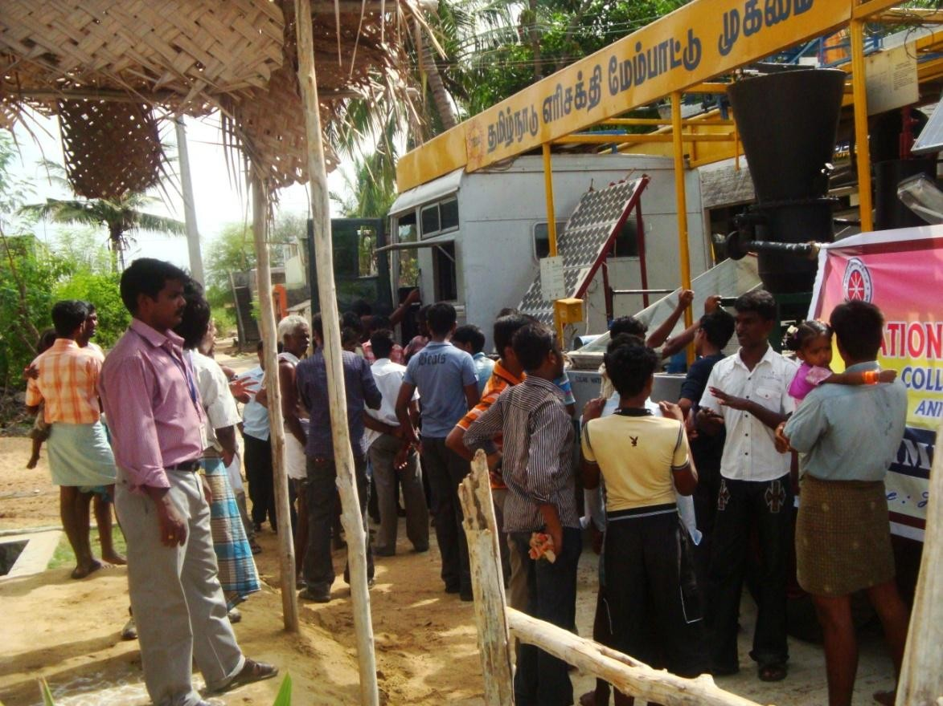
AWARENESS ON RENEWABLE ENERGY - SOLAR STREET LIGHT
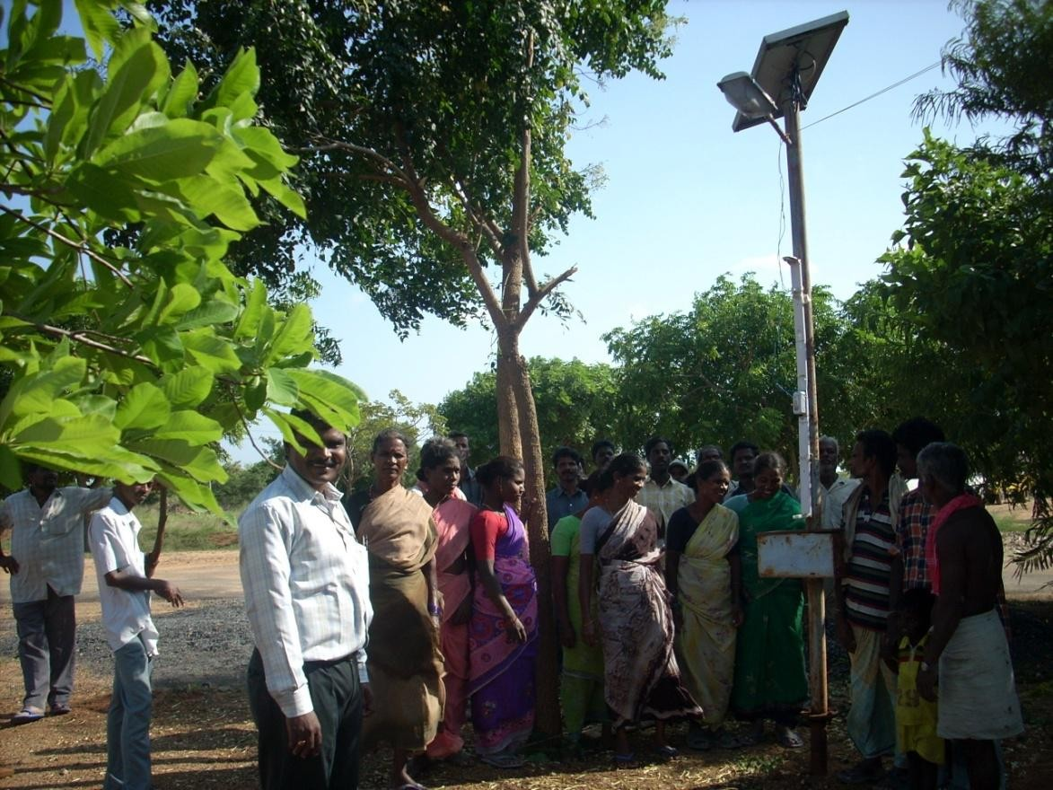

AWARENESS ON RENEWABLE ENERGY - SOLAR WATER HEATER
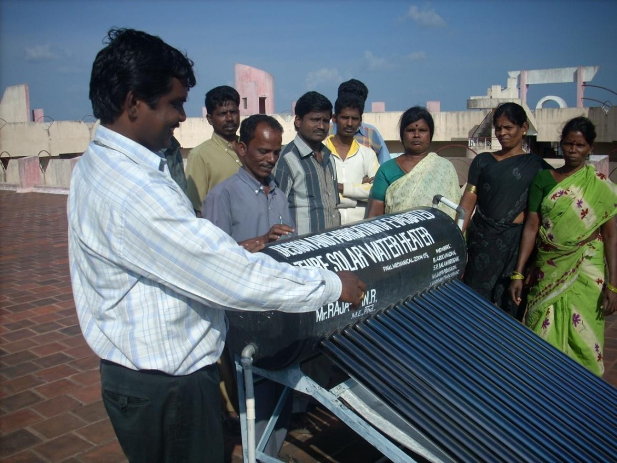
AWARENESS ON RENEWABLE ENERGY - WIND MILL
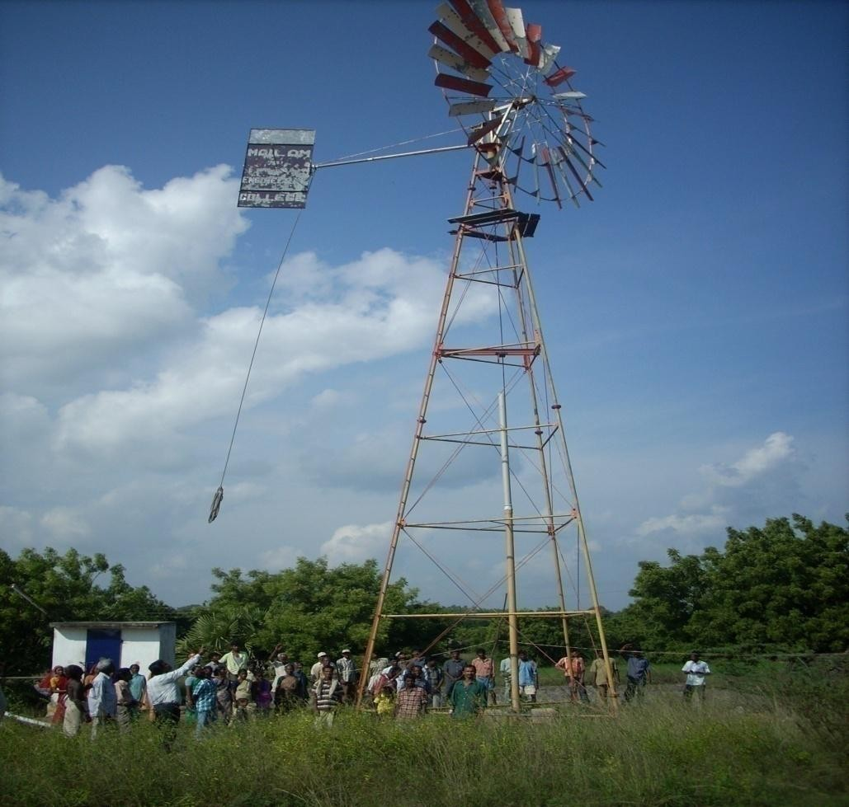

AWARENESS ON RENEWABLE ENERGY - SOLAR COOKER
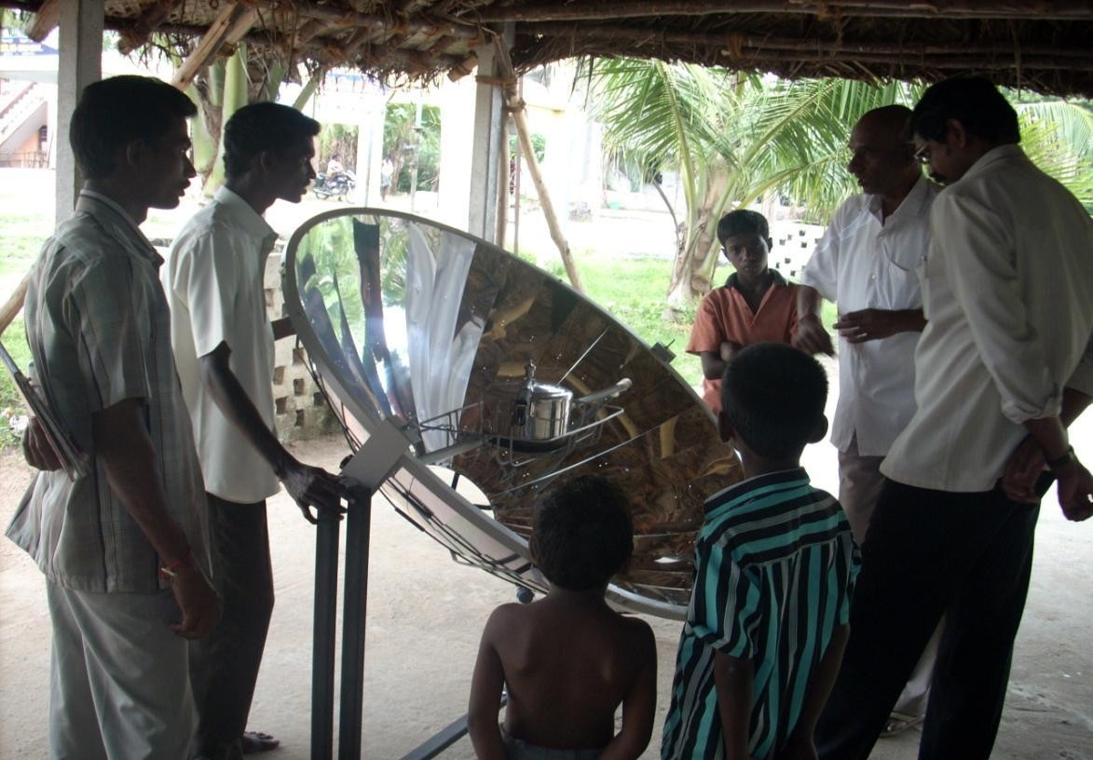
CONDUCTED DRAWING COMPETITION TO PRIMARY SCHOOL CHILDREN
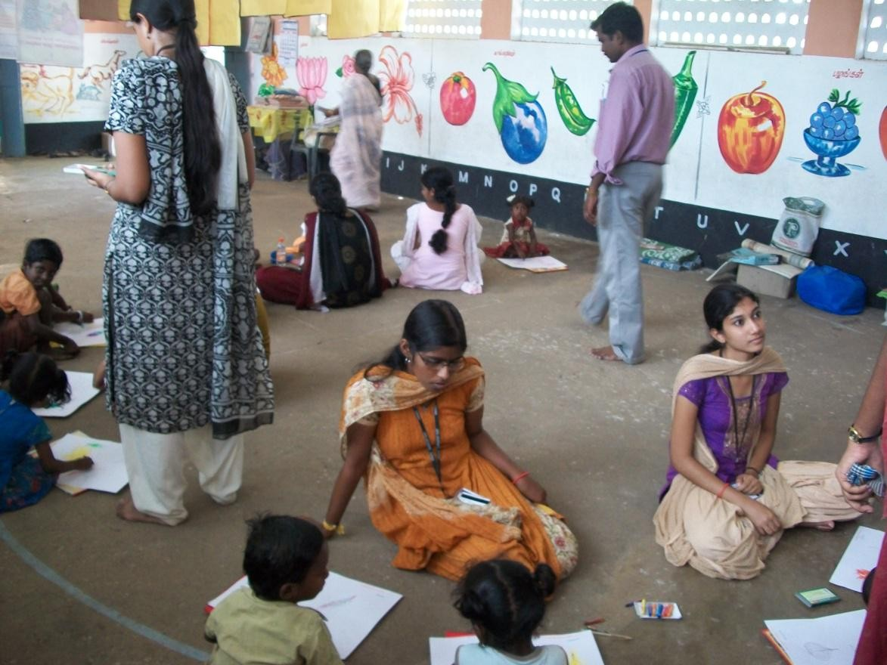

CONDUCTED DRAWING COMPETITION TO PRIMARY SCHOOL CHILDREN
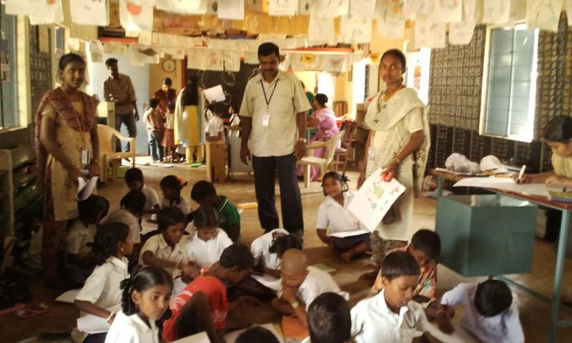

REPUBLIC DAY CELEBRATION

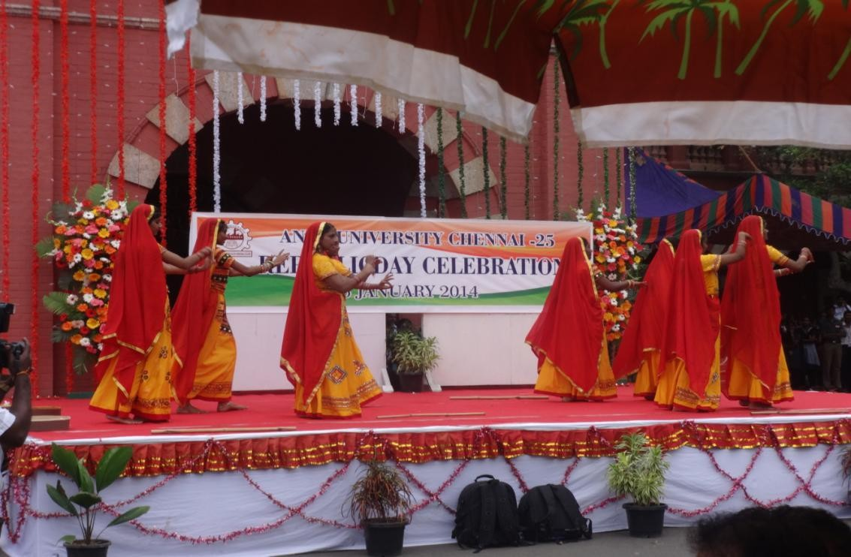

REPUBLIC DAY CELEBRATION

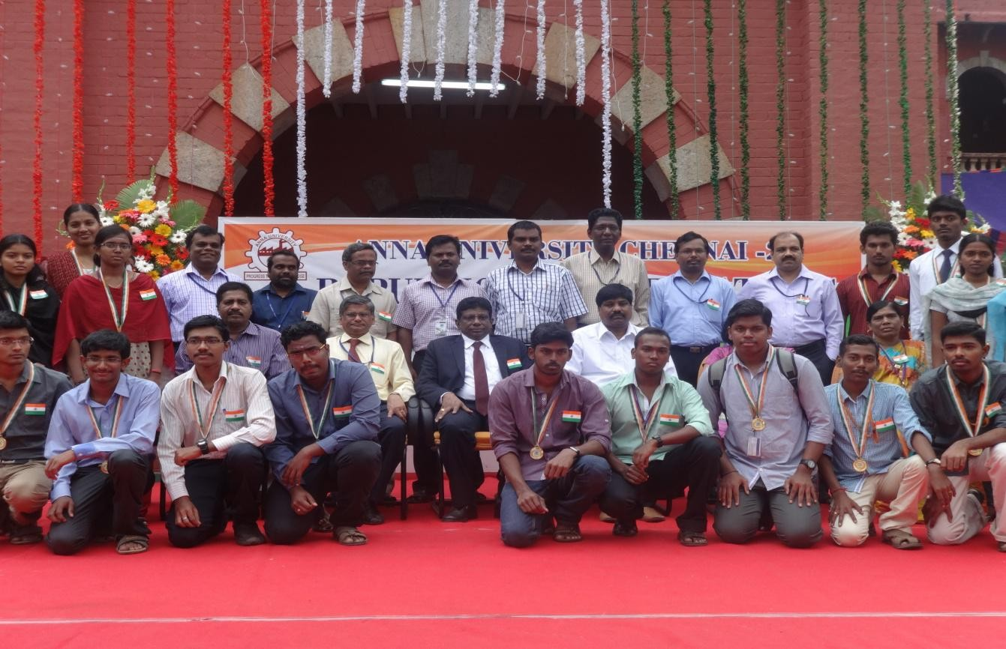

RALLY ON NATIONAL VOTERS DAY CELEBRATION

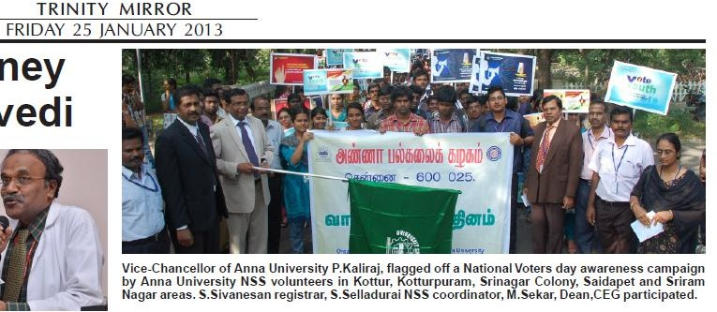

BEST NSS UNIT AWARD 2011-2012
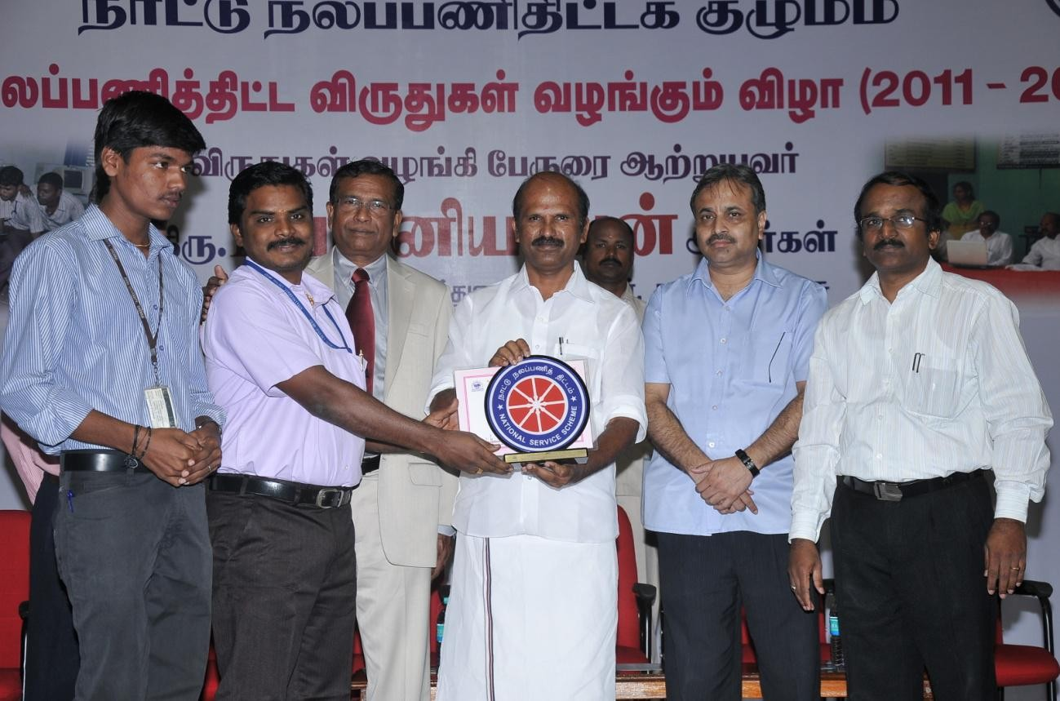

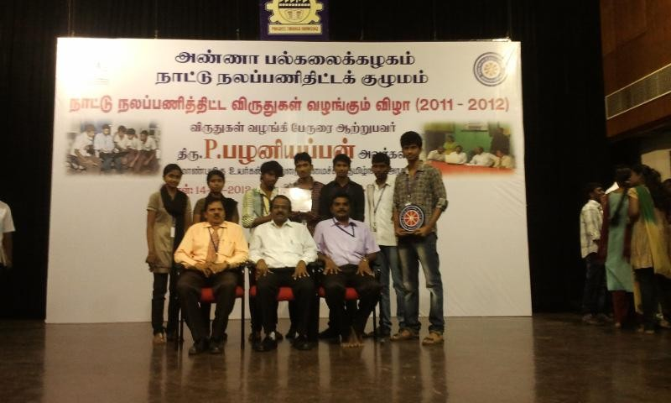

BLOOD DONATION
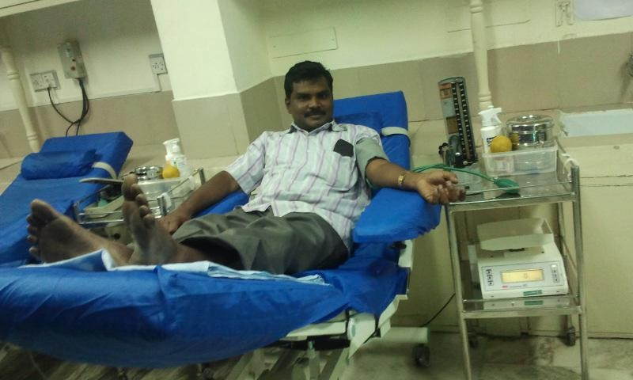

CELEBRATION OF SWAMI VIVEKANANDHA’S 150th BIRTH ANNIVERSARY

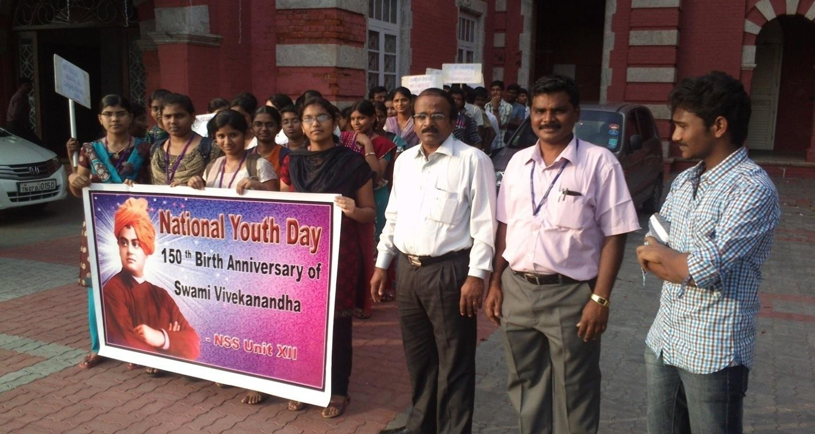

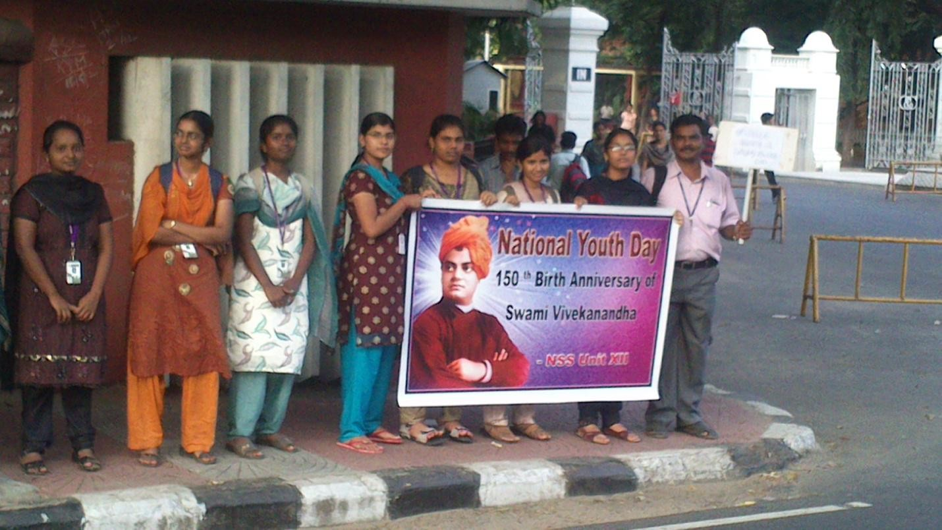

CELEBRATED “WORLD SUICIDE PREVENTION DAY” ON 10th SEPTEMBER. 2013
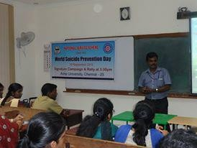

INTERNATIONAL DAY OF YOGA 2018
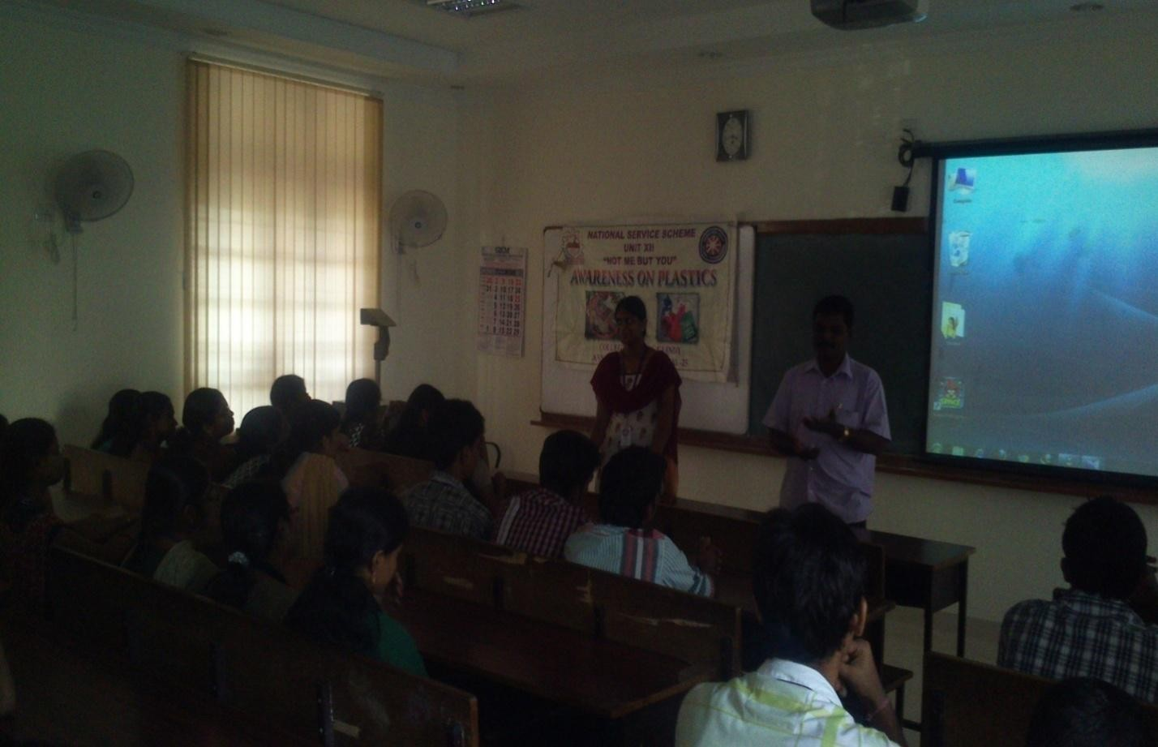
INTERNATIONAL DAY OF YOGA 2018
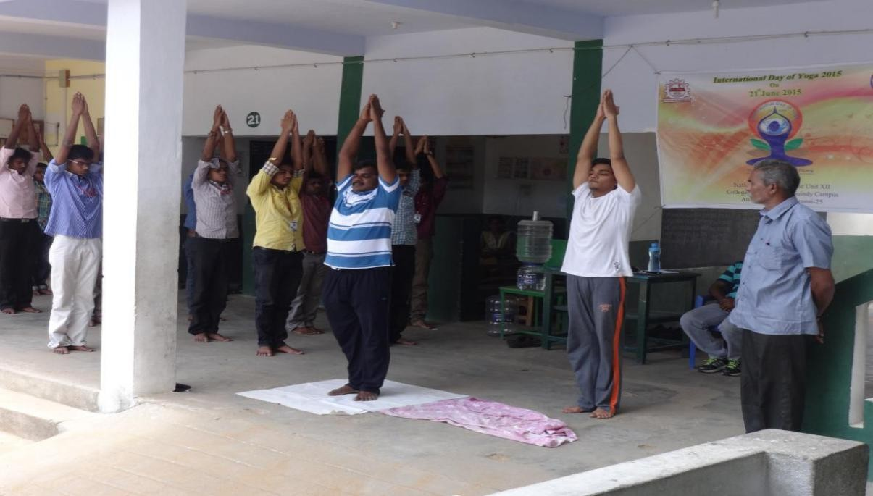

INTERNATIONAL DAY OF YOGA 2018
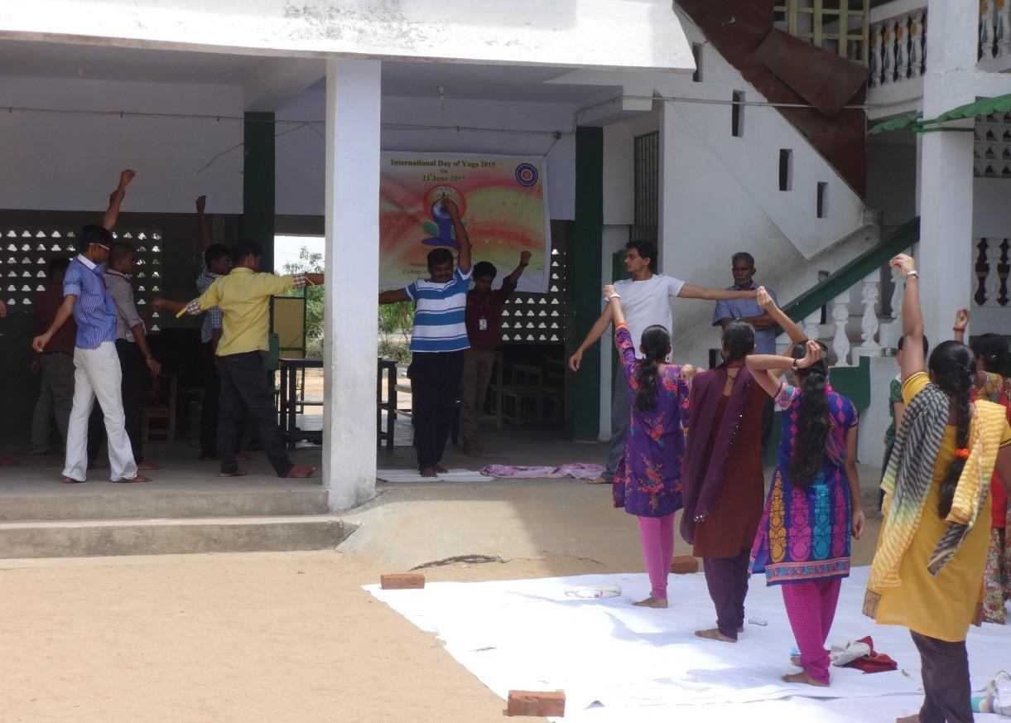
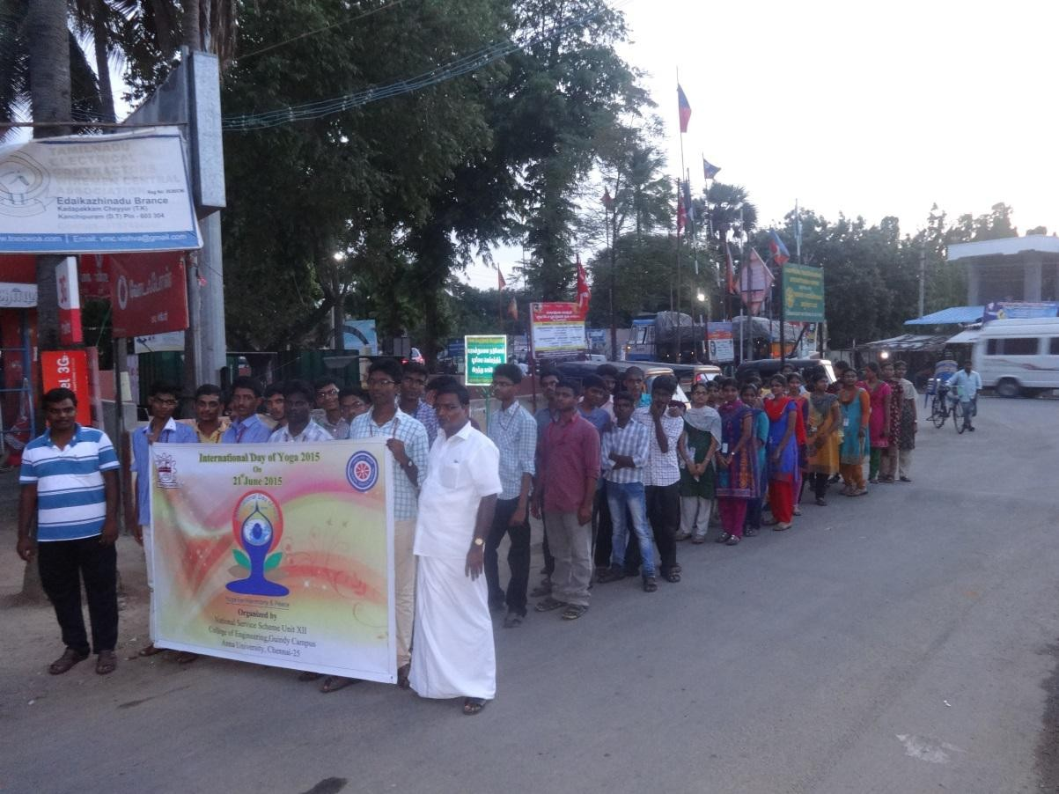

NATIONAL YOUTH POLICY 2014
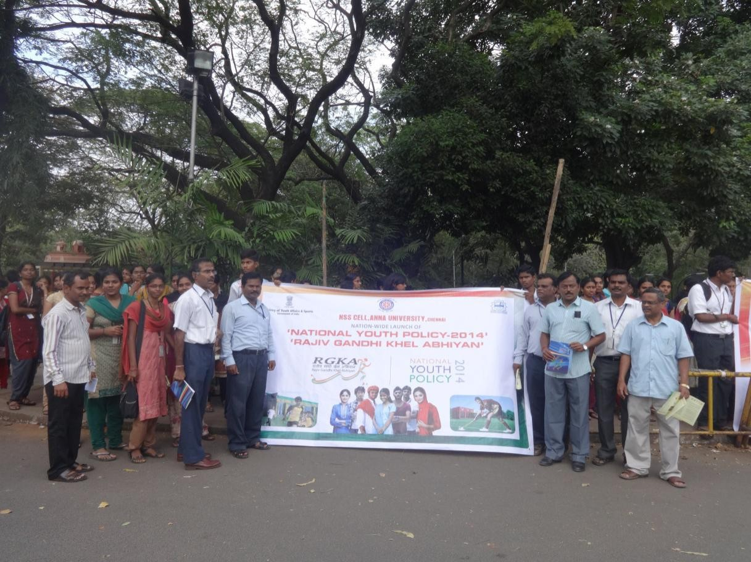

FIRST AID AND DISASTER MANAGEMENT TO OUR VOLUNTEERS AND VILLAGE PEOPLE
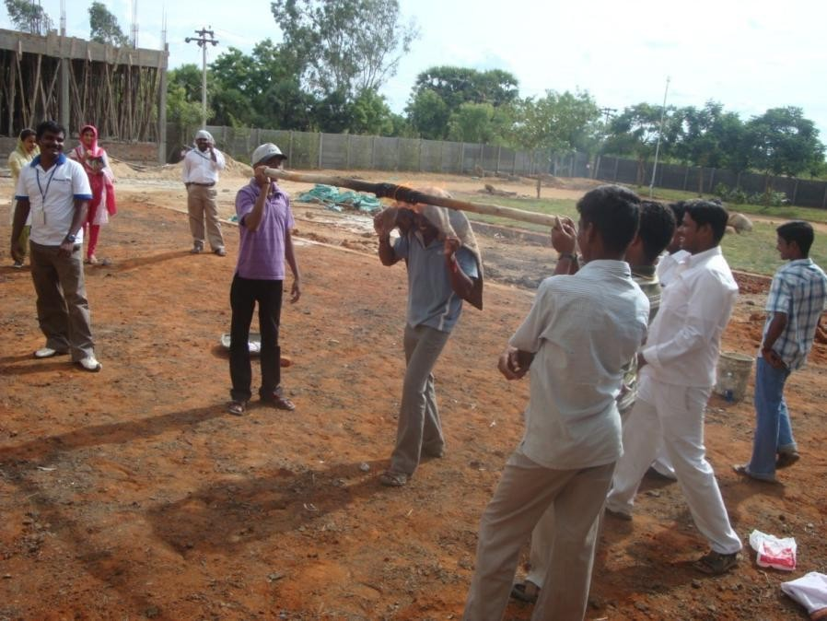

ONE DAY WORKSHOP IN “NSS ACTIVITY”
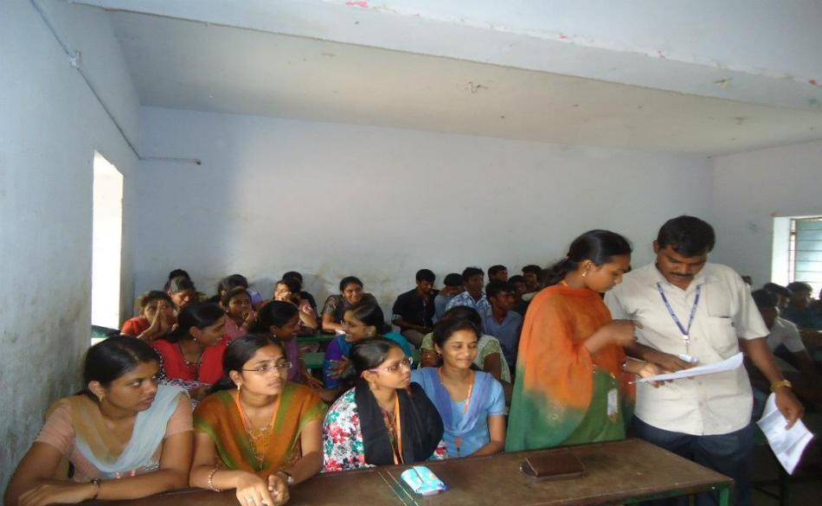

REPUBLIC DAY:
.
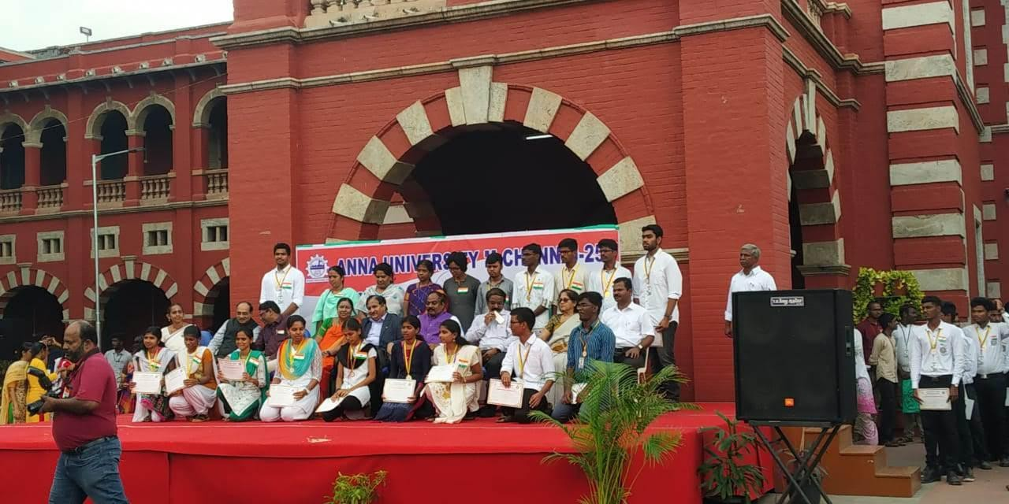

Blood Donation Camp : DROPS OF HOPE – ‘spread your red’

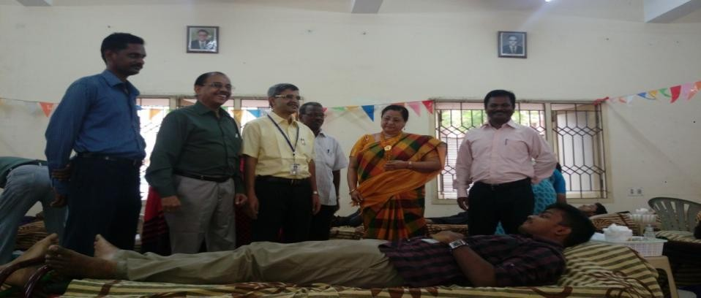

Digital India Program
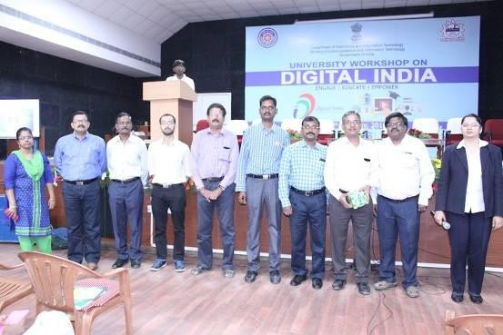
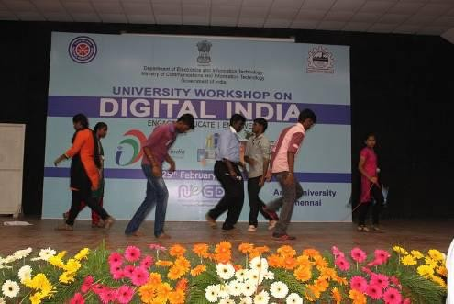

International Youth Exchange Programme

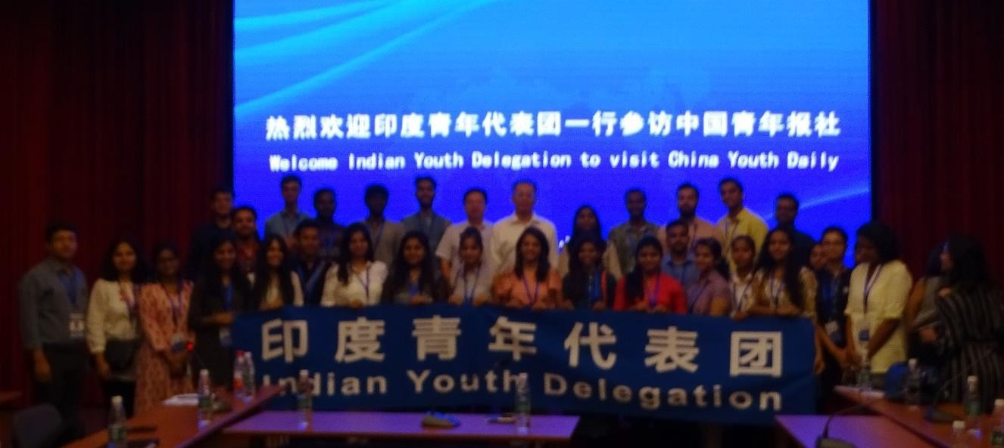

.INTERNATIONAL YOGA DAY CELEBRATION:

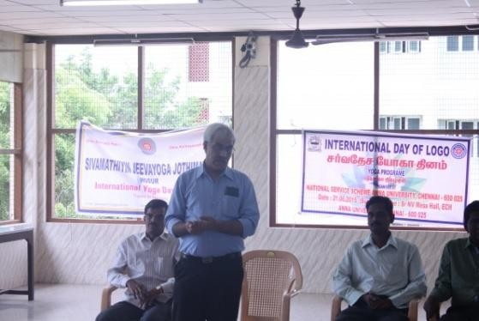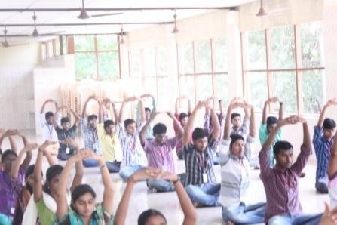

PATRIOTIC SINGING COMPETITION:

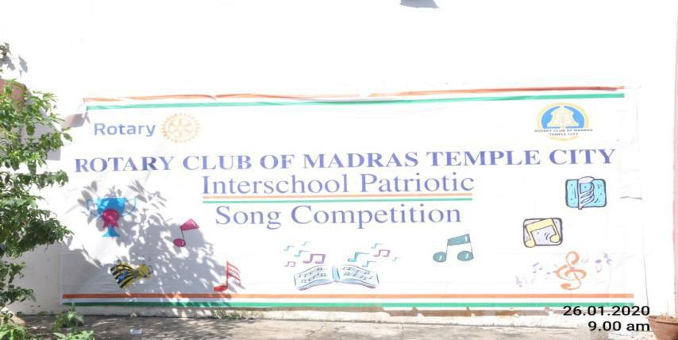

SINGING COMPETITION

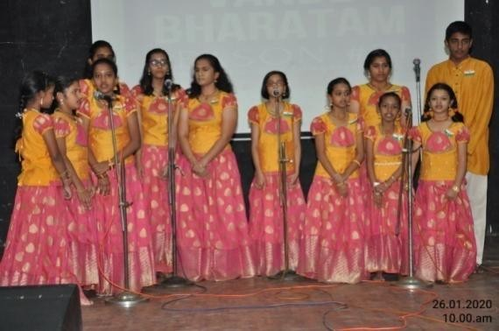

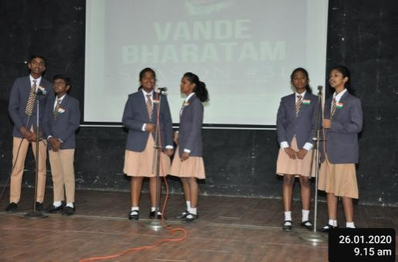
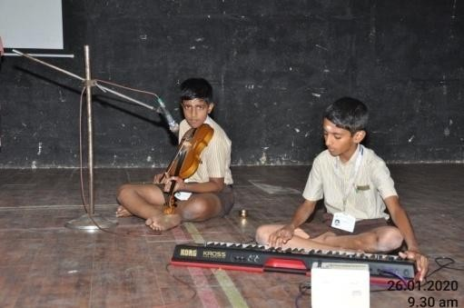

ACTIVITIES DURING SINGING COMPETITION

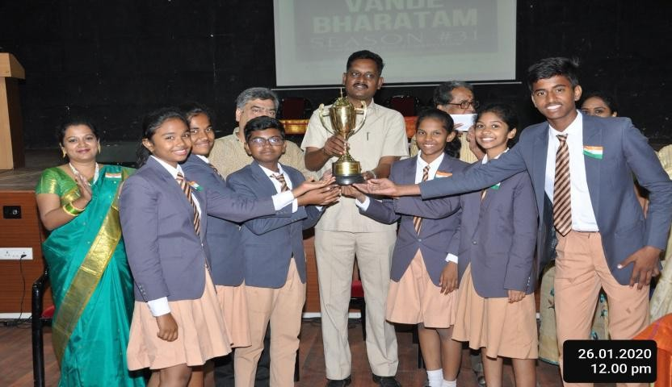

AATRAL (AAGACHIRADHAVAN)

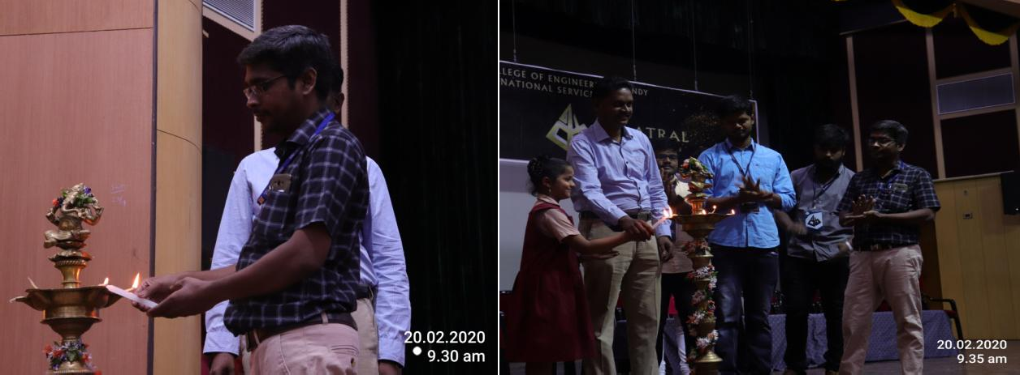
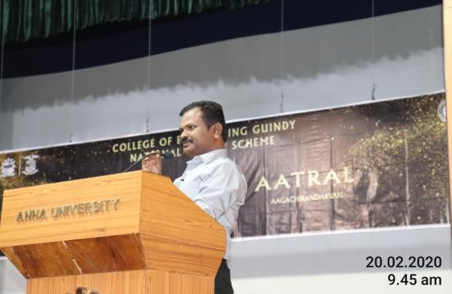
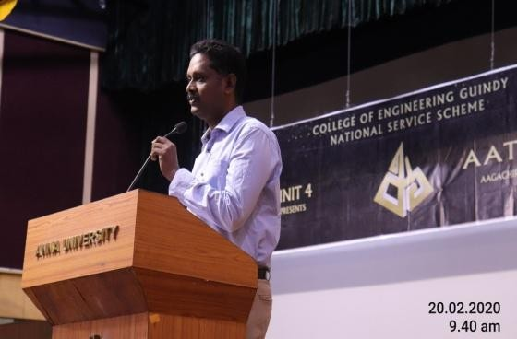

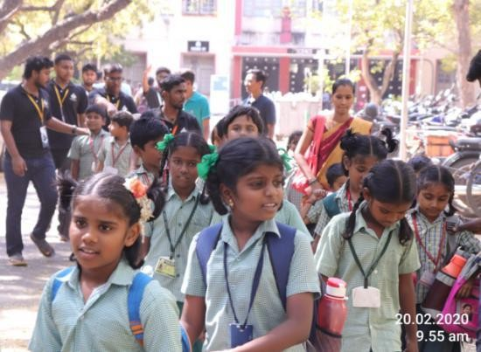

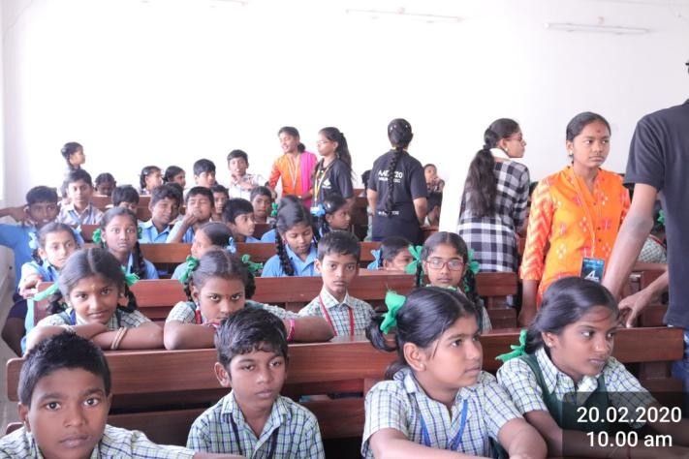

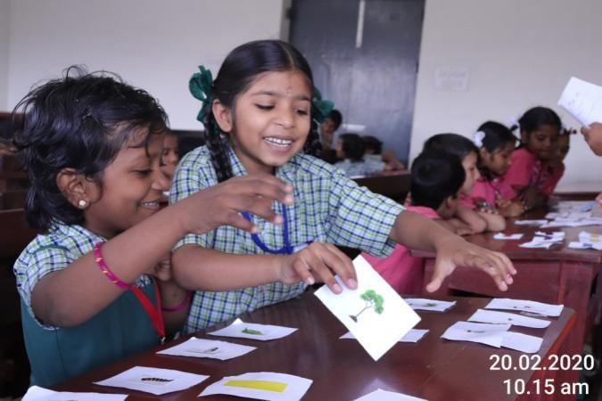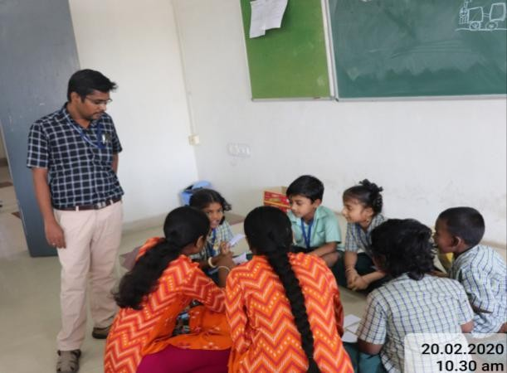

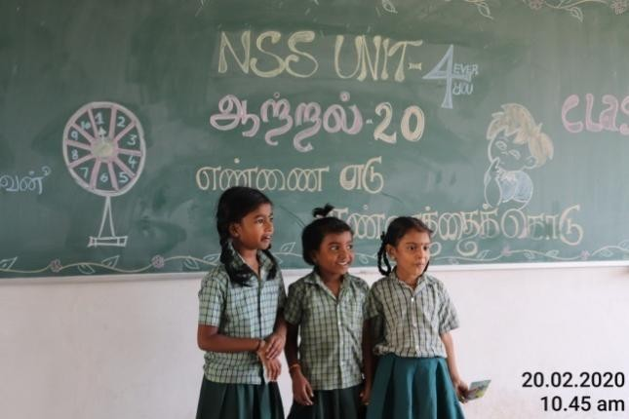
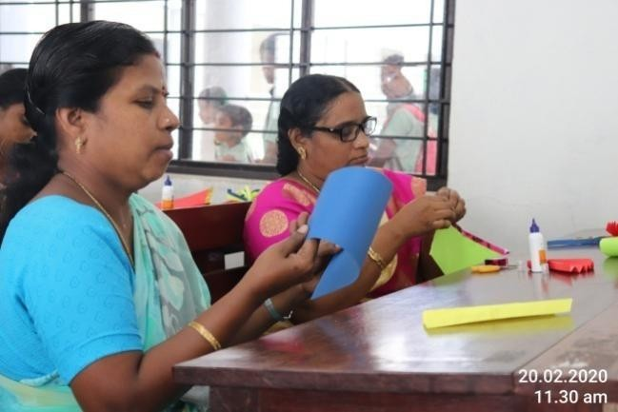

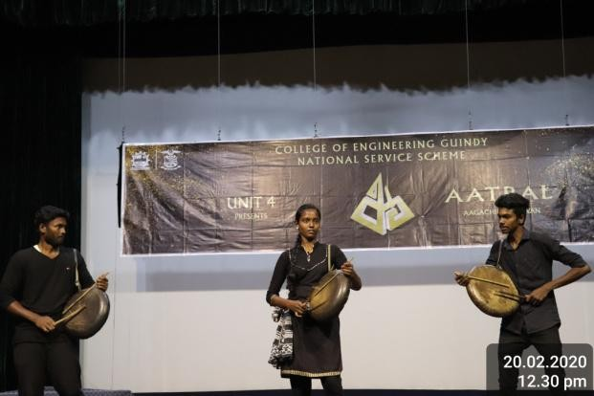
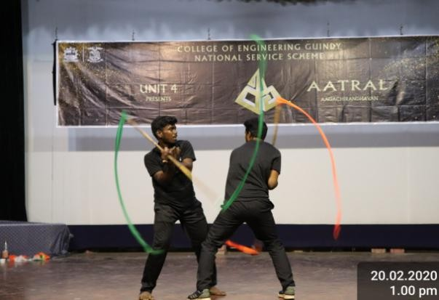

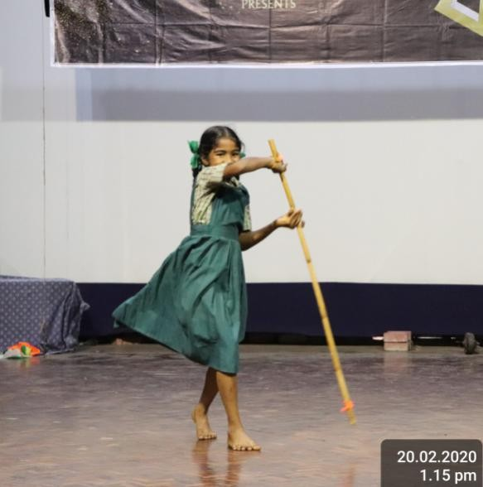
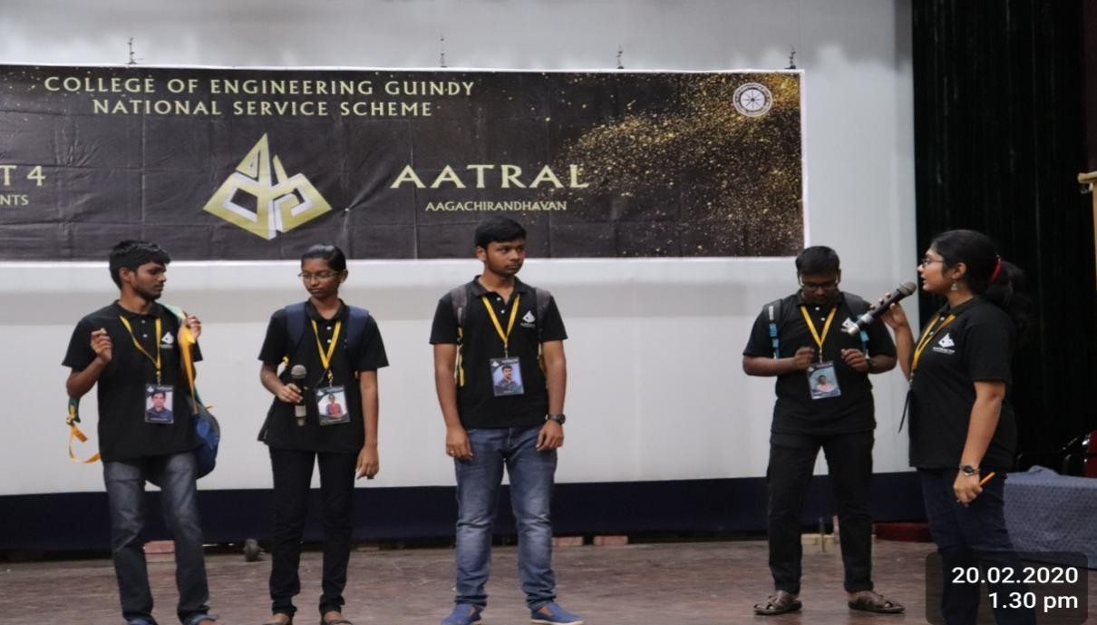

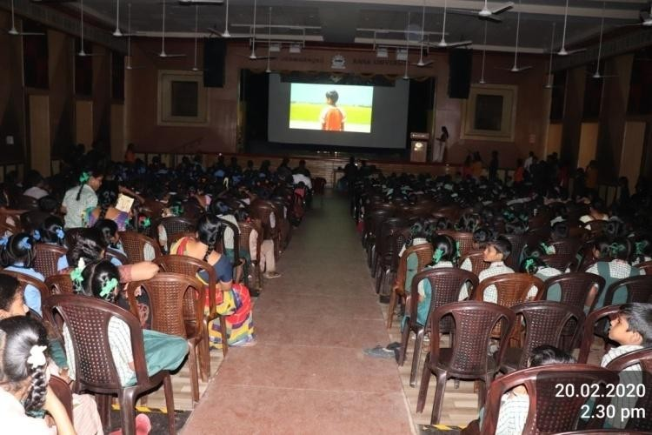

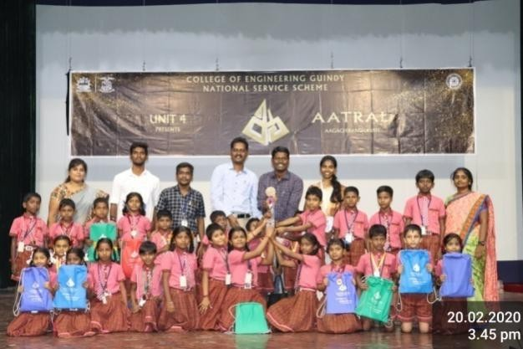

NATIONAL VOTERS DAY