Special Camping Programme

The camps are held during vacation for 7 days in the communities adopted by the concerned NSS units. The campers consist of the Programme Officers, Student Volunteers and youth. The various projects undertaken could involve developmental work, health and sanitation campaigns, survey work, educational project and other relief work. These projects also create durable assets (roads, wells/ponds, soak pits, etc.), provide support to local developmental programmes and form important links between the people and development agencies.

AWARENESS ON TREE PLANTATION:
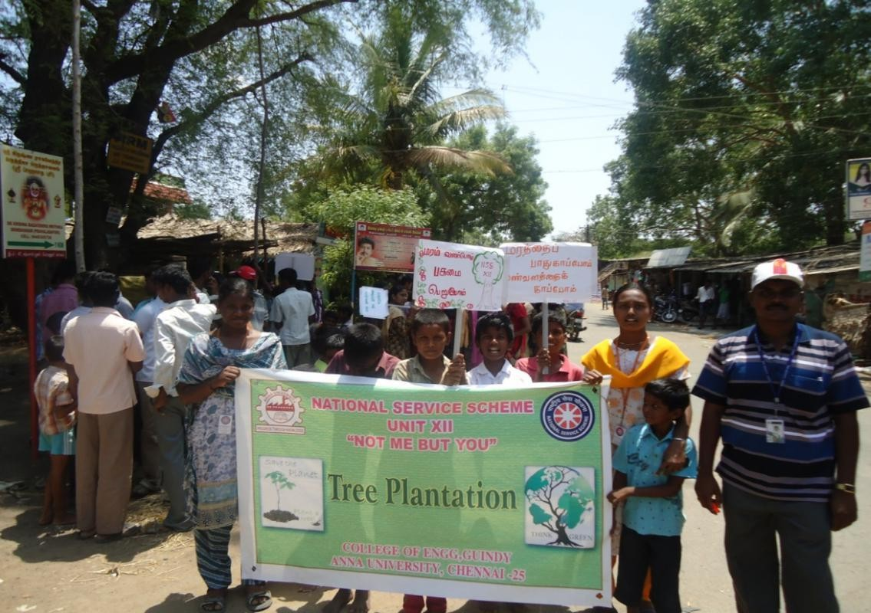

A DRAMA ON AWARENESS ON TREE PLANTATION:
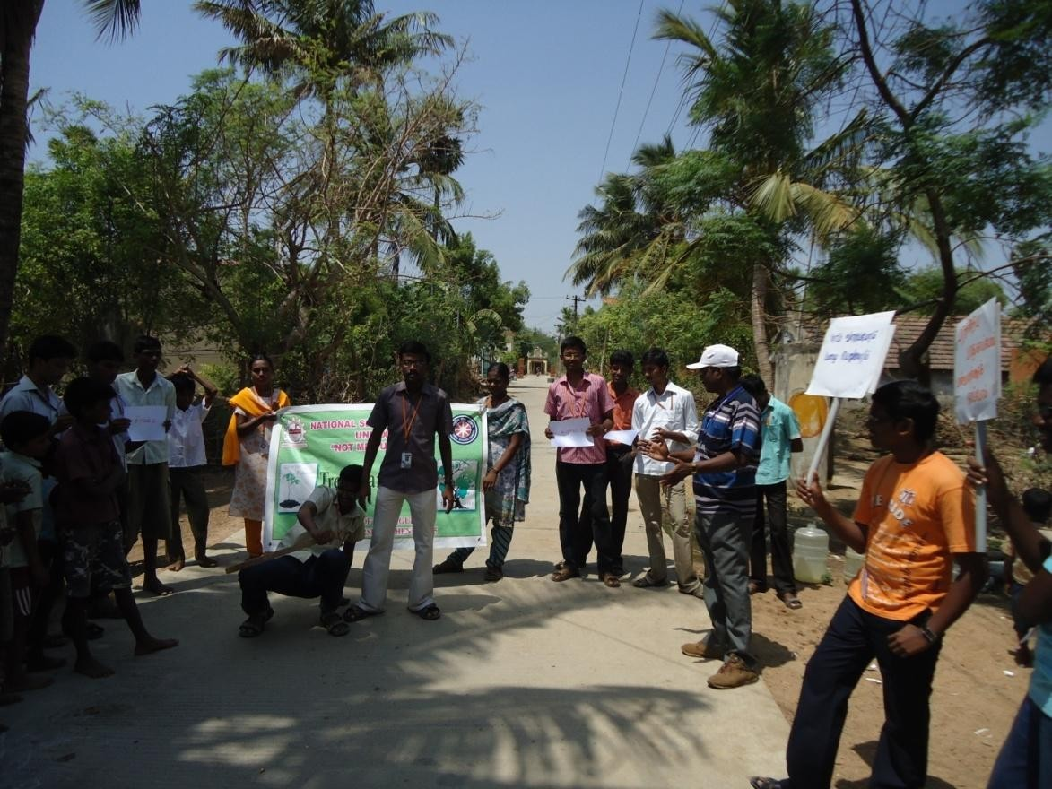

TREE PLANTATION BY PROGRAMME OFFICER
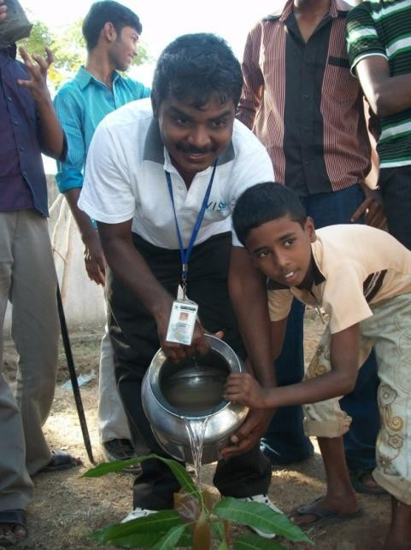

VOTERS AWARENESS IN ADOPTED VILLAGE FOR 100%
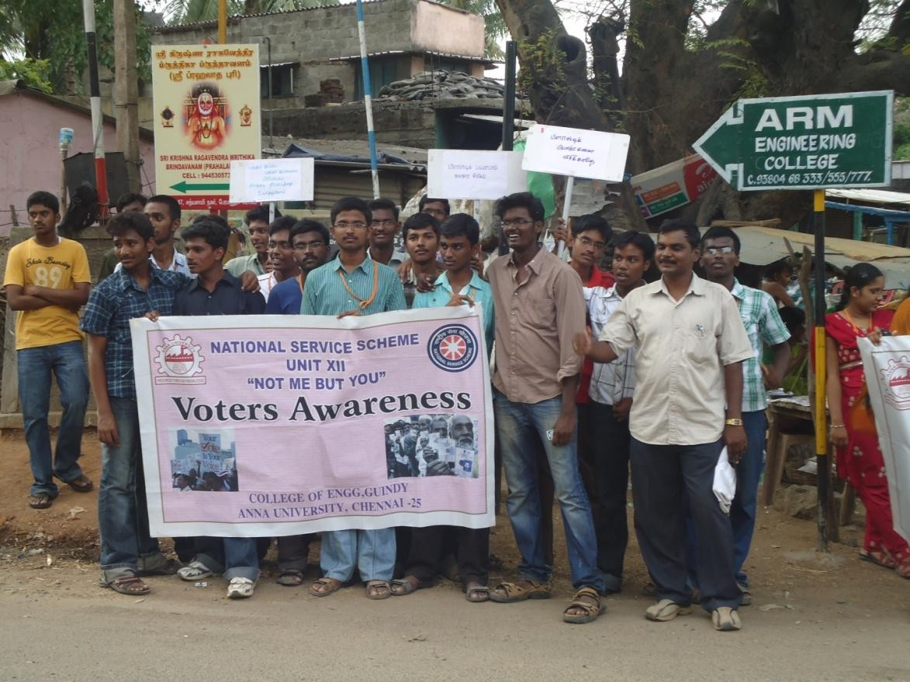

AIDS & CANCER AWARESS IN ADOPTED VILLAGE FOR 100% NO AIDS & NO CANCER
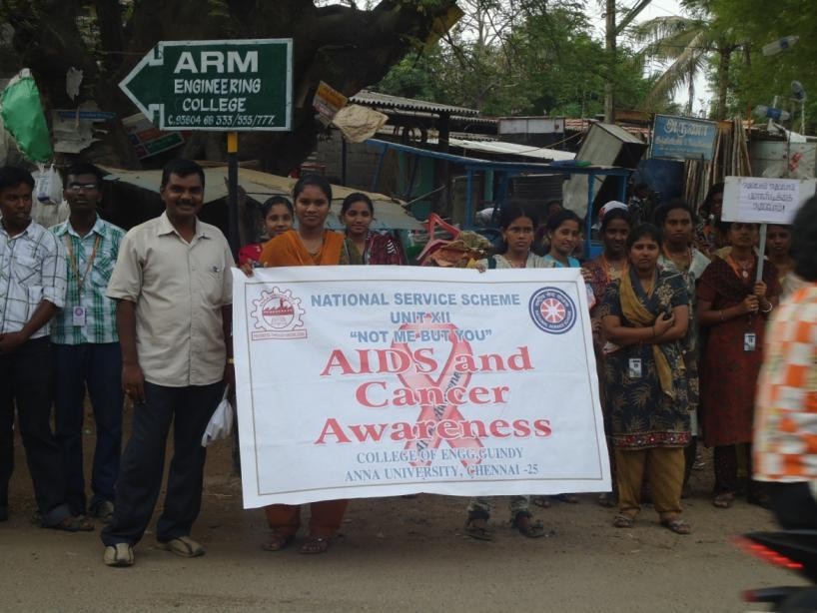

RAIN WATER HARVESTING TO INCREASE THE WATER LEVEL IN THE EARTH FOR DRINKING WATER
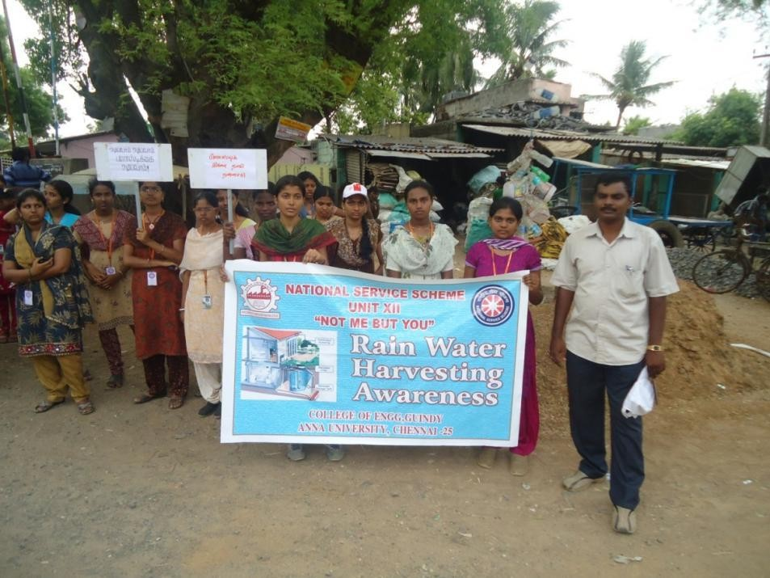

GO PLASTICS IN THE ADOPTED VILLAGE
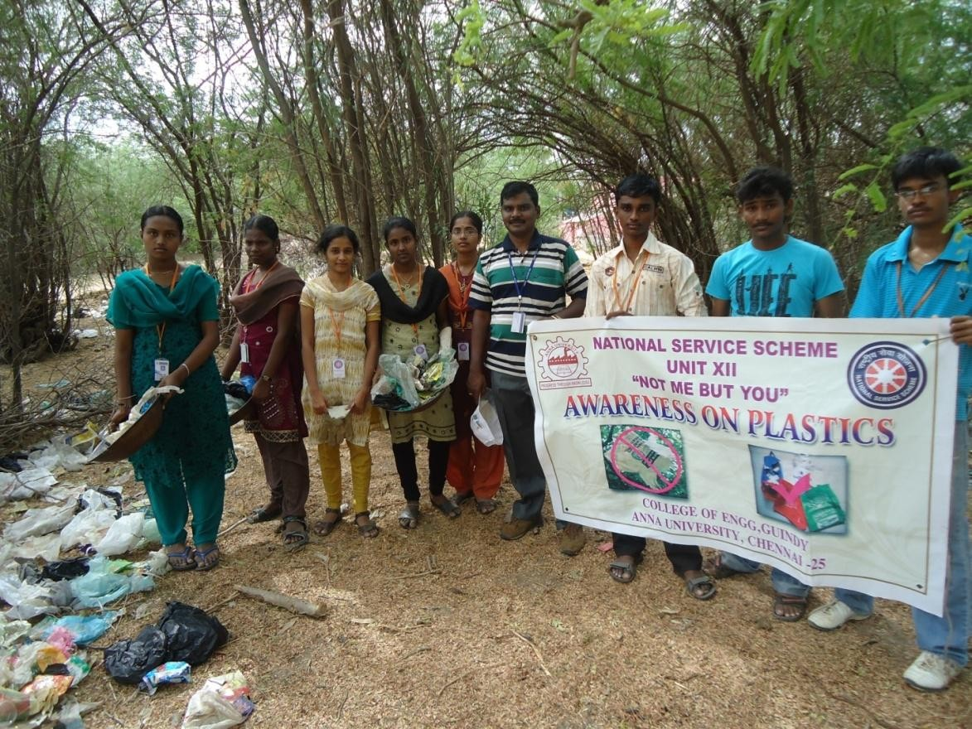

GO PLASTICS IN THE ADOPTED VILLAGE
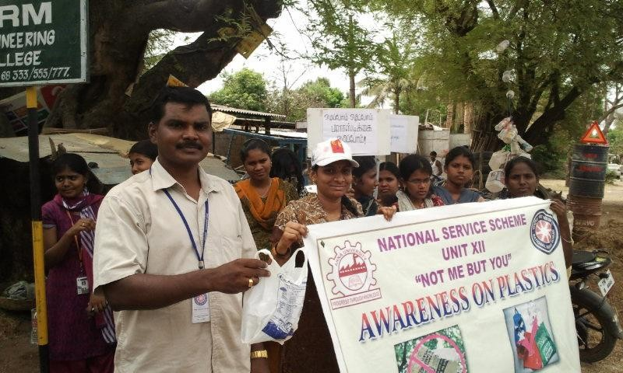

AWARENESS ON EYE DONATION
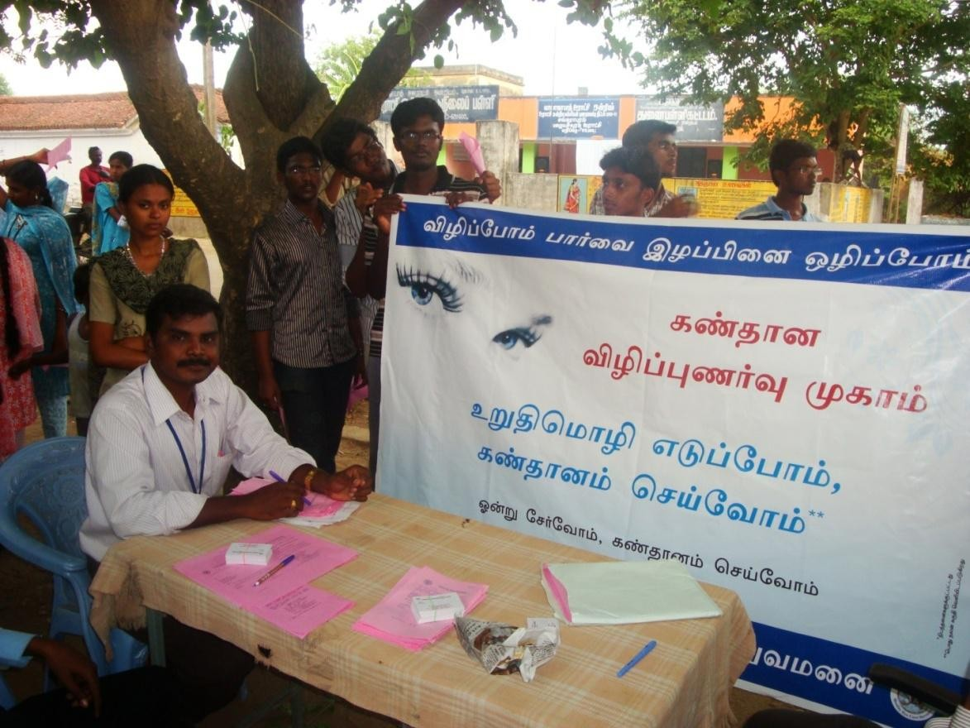
FIRST AID AND DISASTER MANAGEMENT TO OUR VOLUNTEERS AND VILLAGE PEOPLE
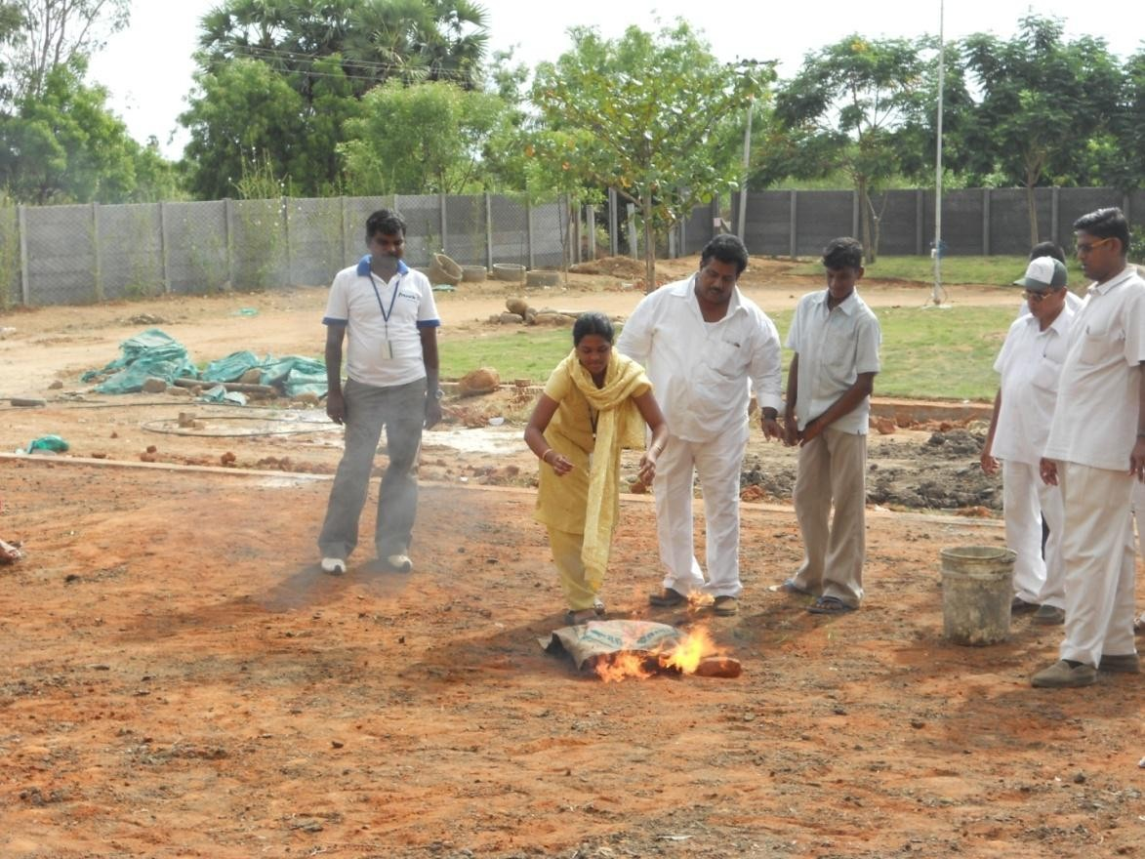

FIRST AID AND DISASTER MANAGEMENT TO OUR VOLUNTEERS AND VILLAGE PEOPLE
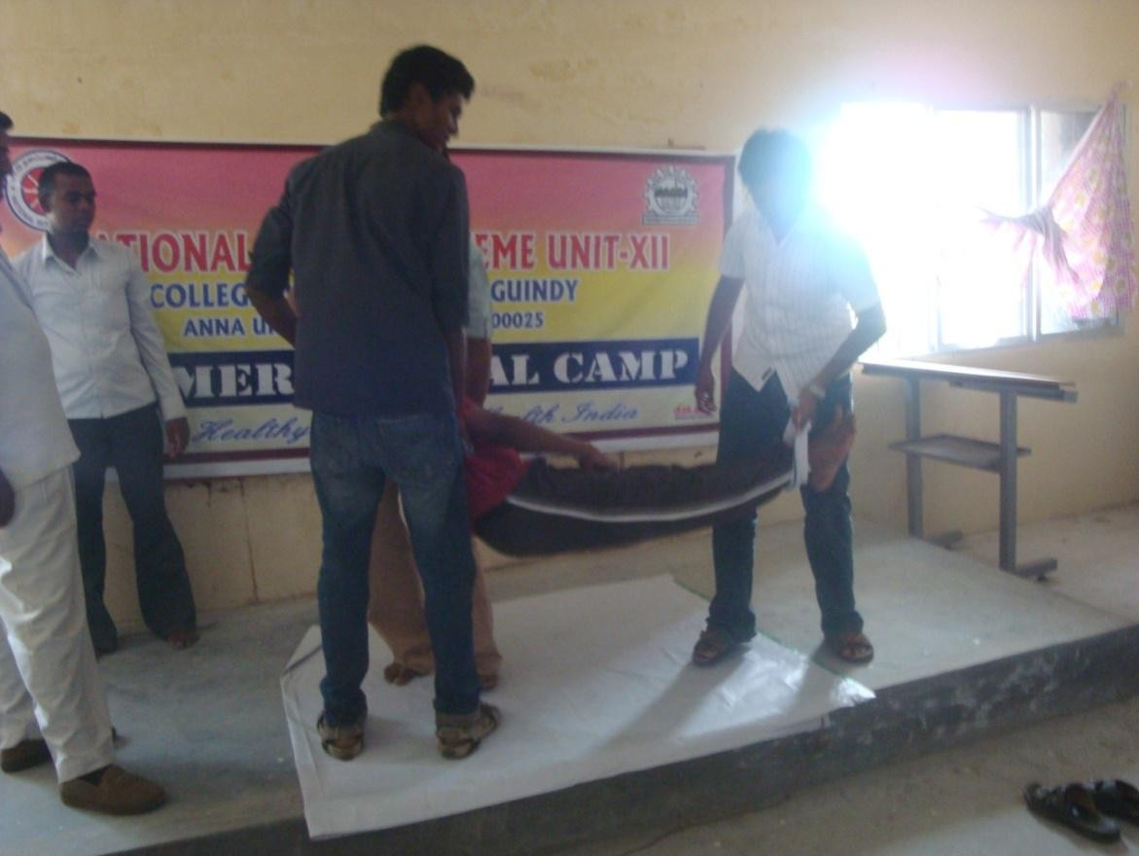

FREE VETERINARY CAMP IN THE ADOPTED VILLAGE
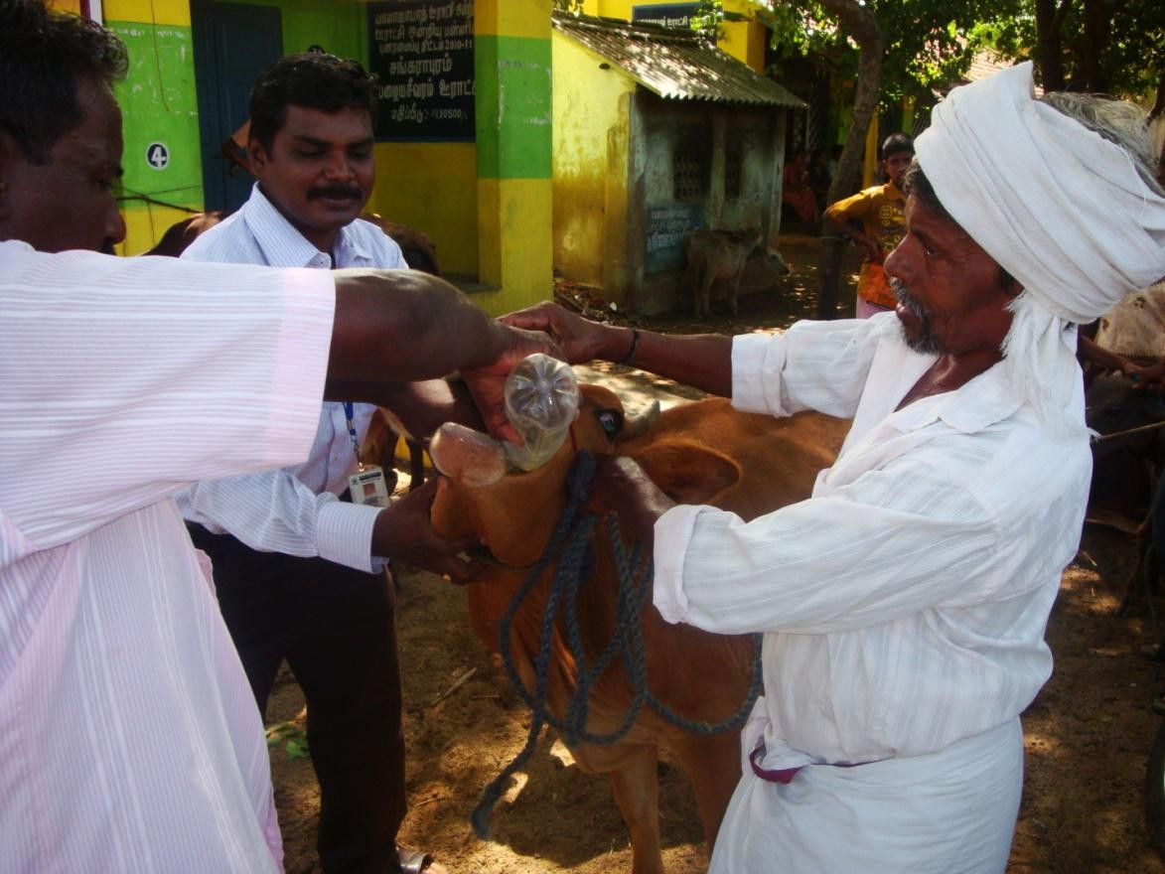
FREE VETERINARY CAMP IN THE ADOPTED VILLAGE
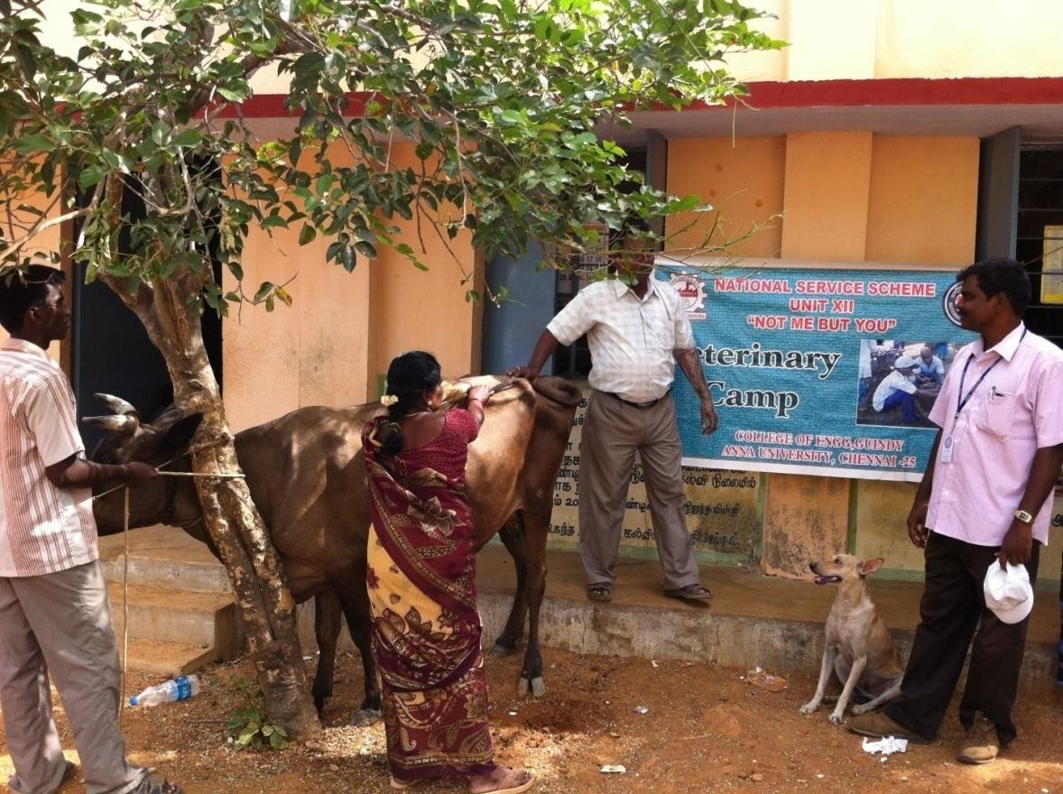

FREE EYE CAMP IN THE ADOPTED VILLAGE
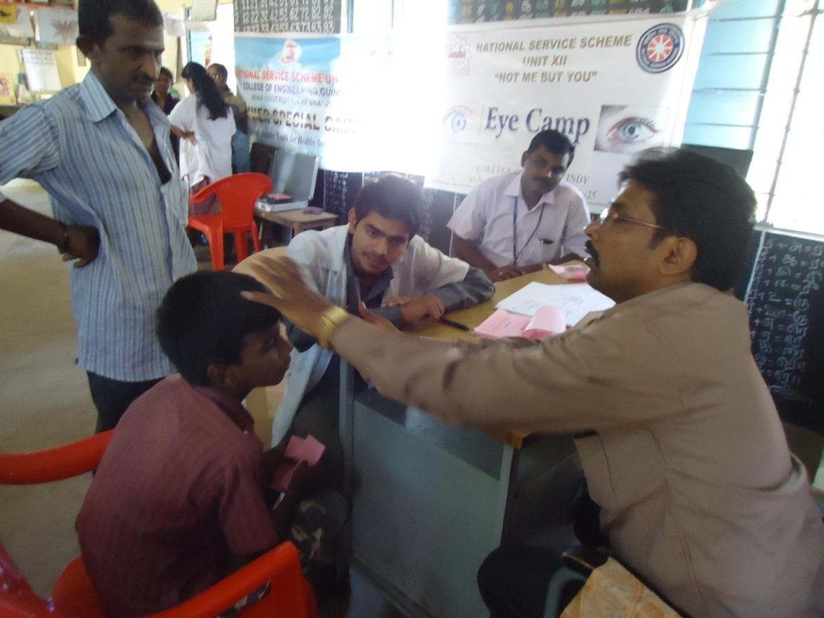

LAPTOP TRAINING FOR SCHOOL CHILDREN
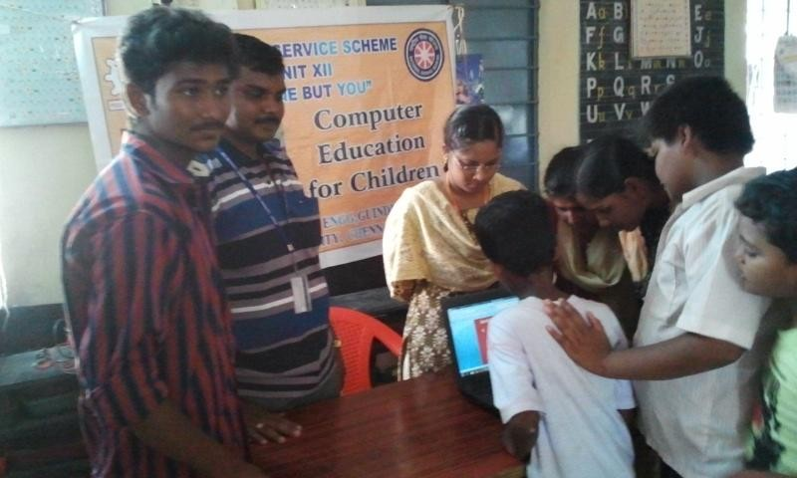

COMPUTER HARDWARE TRAINING FOR SCHOOL CHILDREN
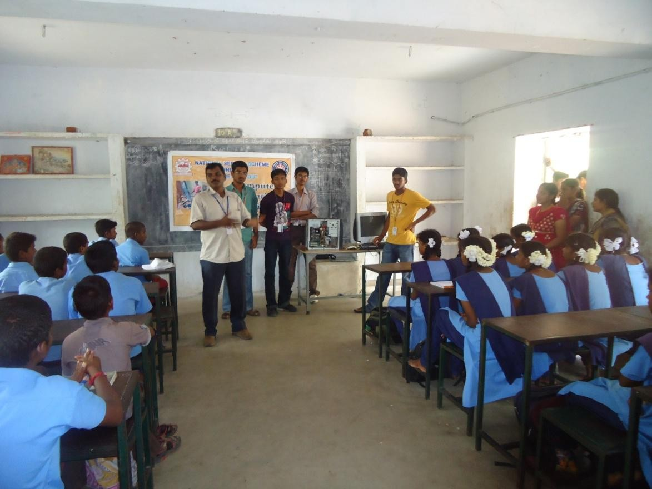

AWARENESS ON HIGHER EDUCATION FOR HIGHER SECONDARY SCHOOL CHILDREN
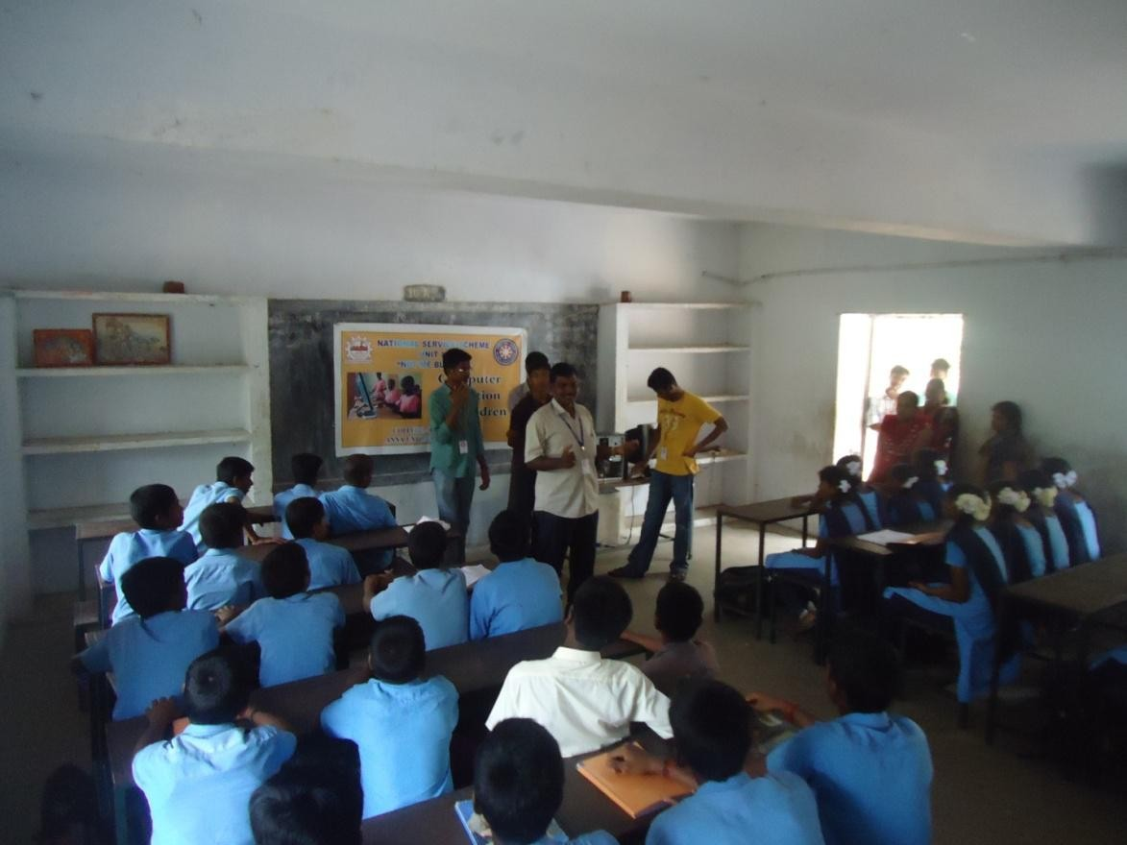

SURVEY IN THE VILLAGE
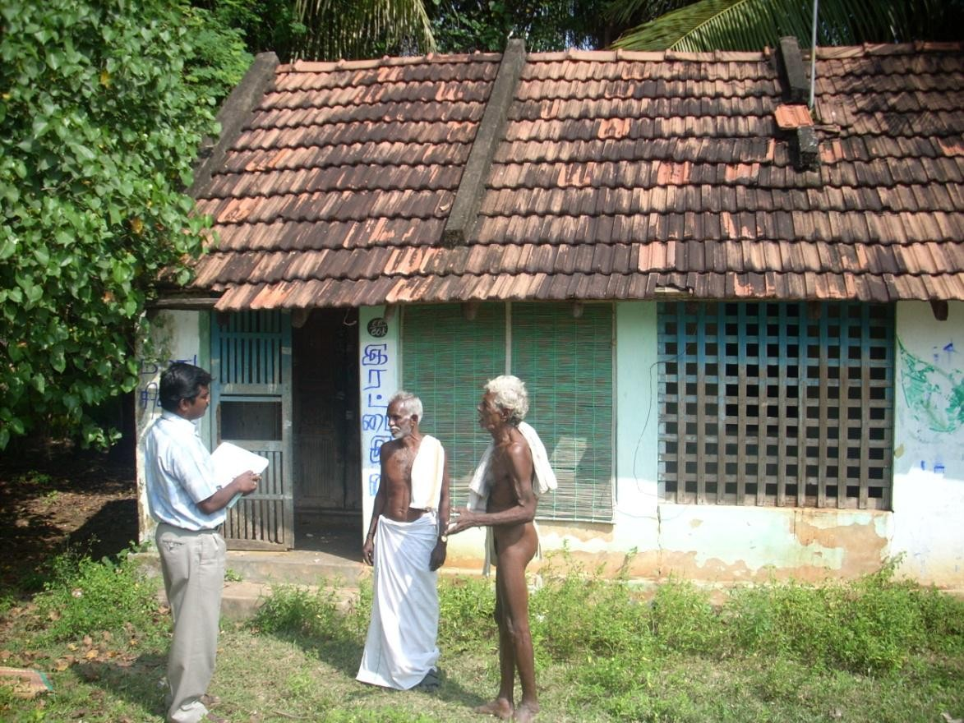
SURVEY IN THE VILLAGE
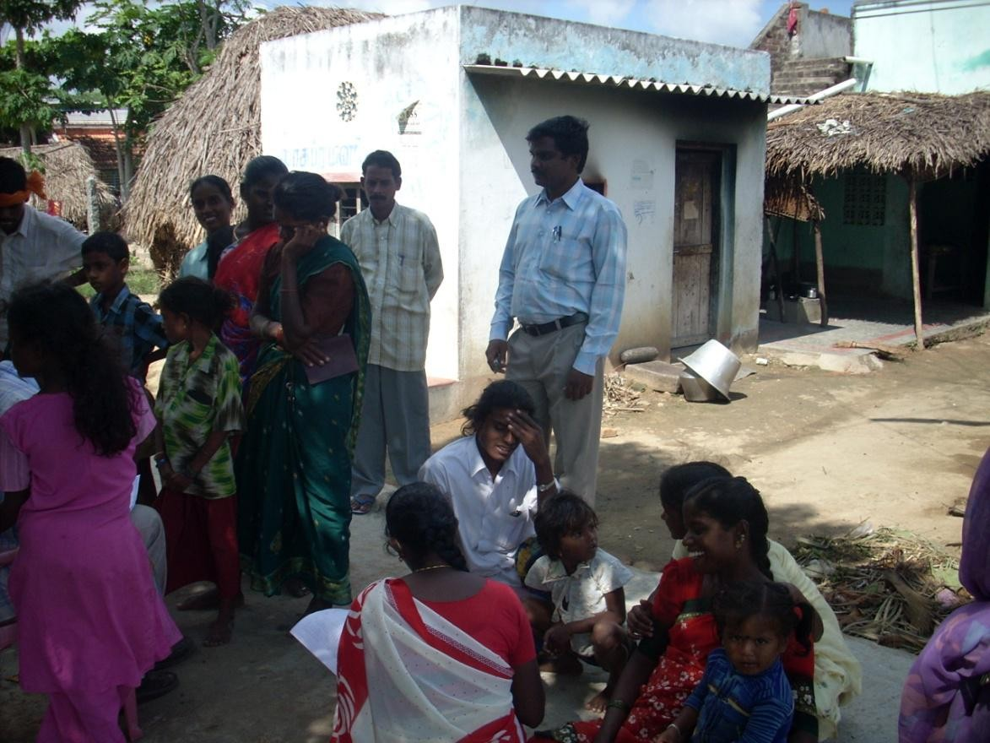

CONDUCTED SPORTS COMPETITION TO PRIMARY SCHOOL CHILDREN
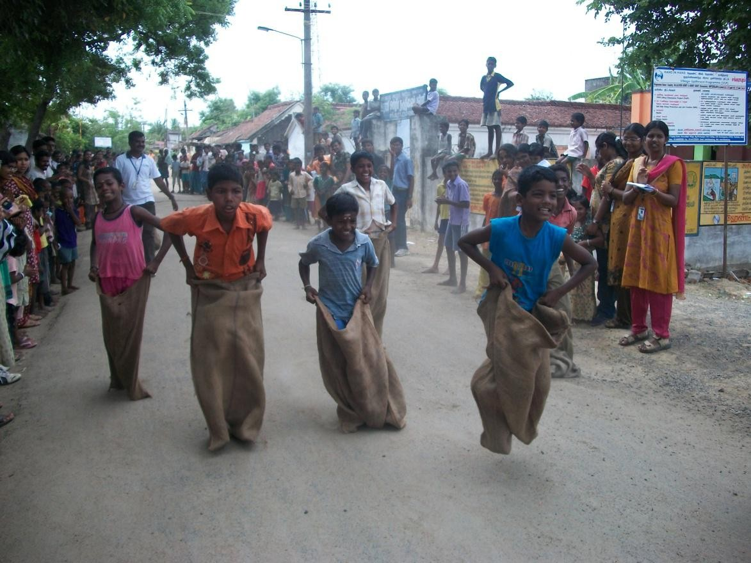

TECHNICAL TRAINING TO YOUTH & SELF GROUP
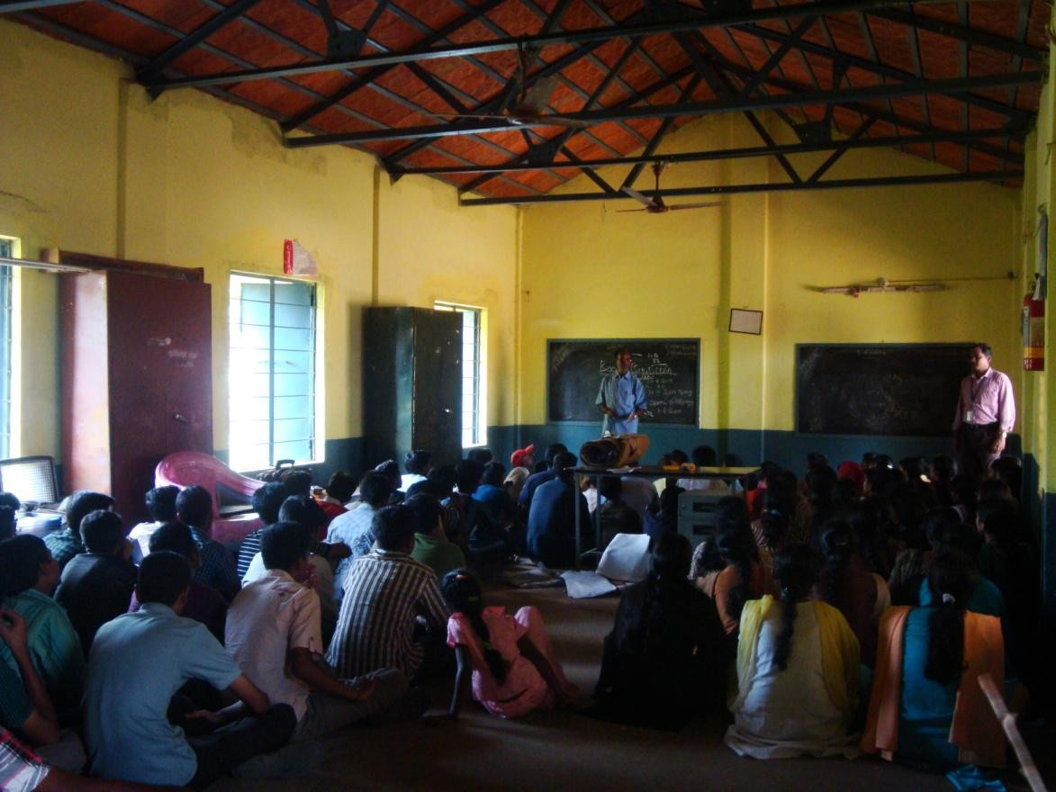

PRIZE DISTRIBUTION TO WINNERS
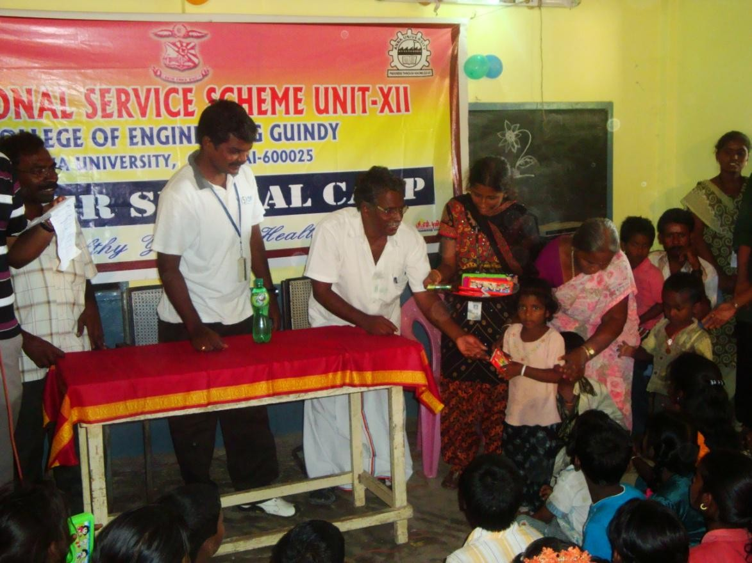

PRIZE DISTRIBUTION TO WINNERS
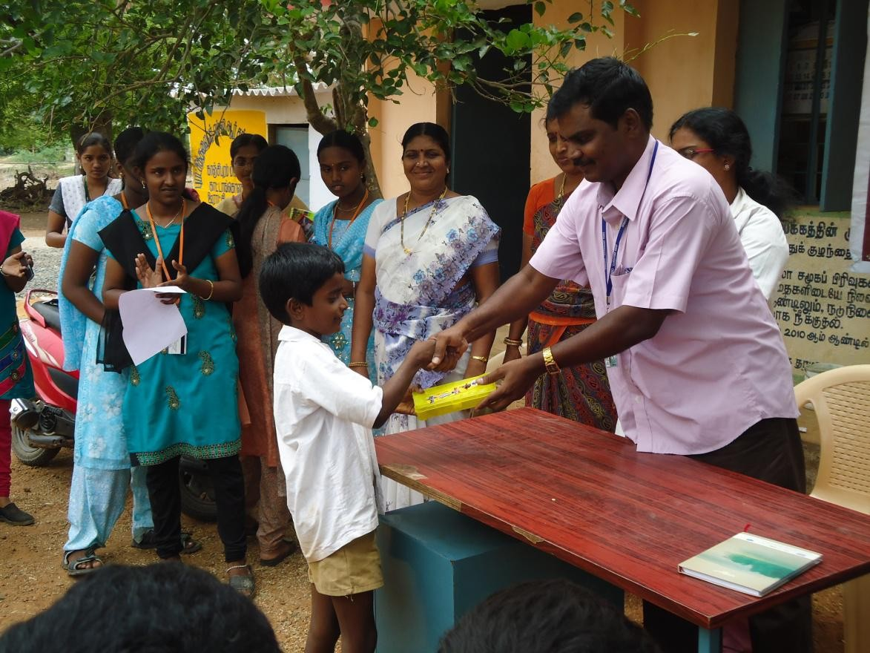

TAKING FOOD WITH PRIMARY SCHOOL CHILDREN
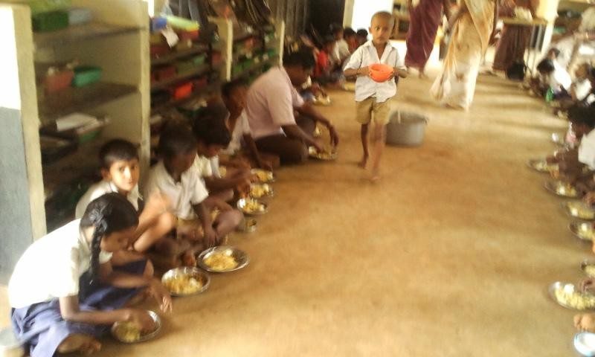

FELICITATION TO AYAMMA
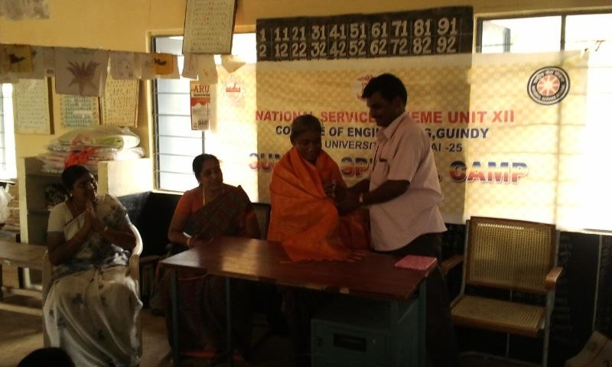

A TALK ON ENVIRONMENTAL ISSUES TO VILLAGE PEOPLE
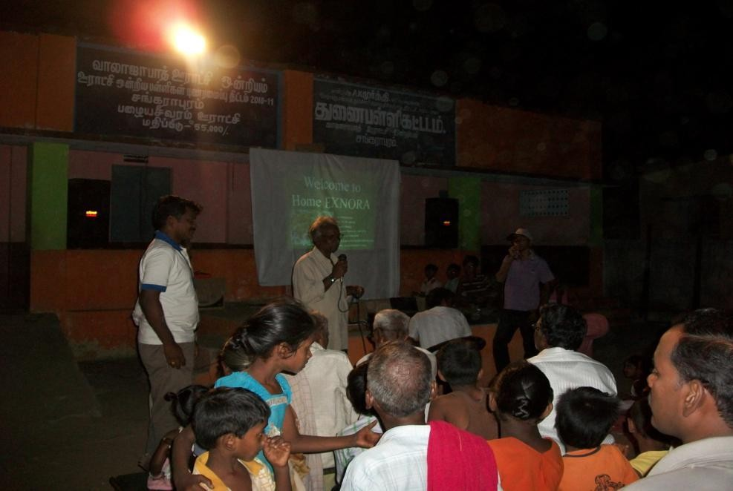

PROGRAMME OFFFICER WITH SCHOOL CHILDREN
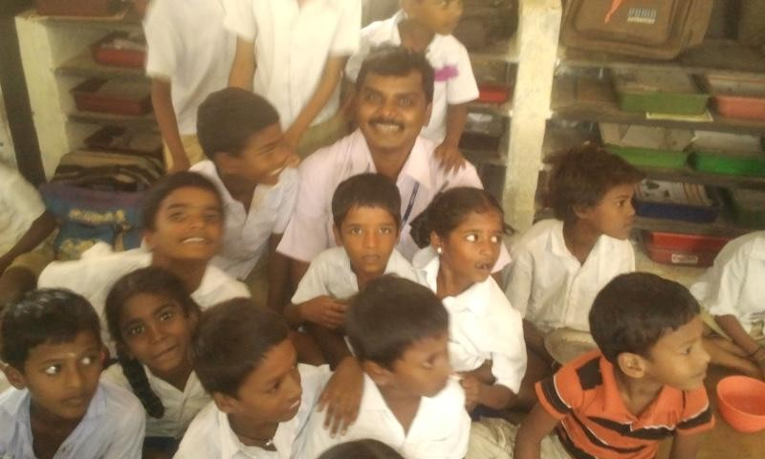

CANCER AWARENESS PROGRAMME TO VILLAGE PEOPLE
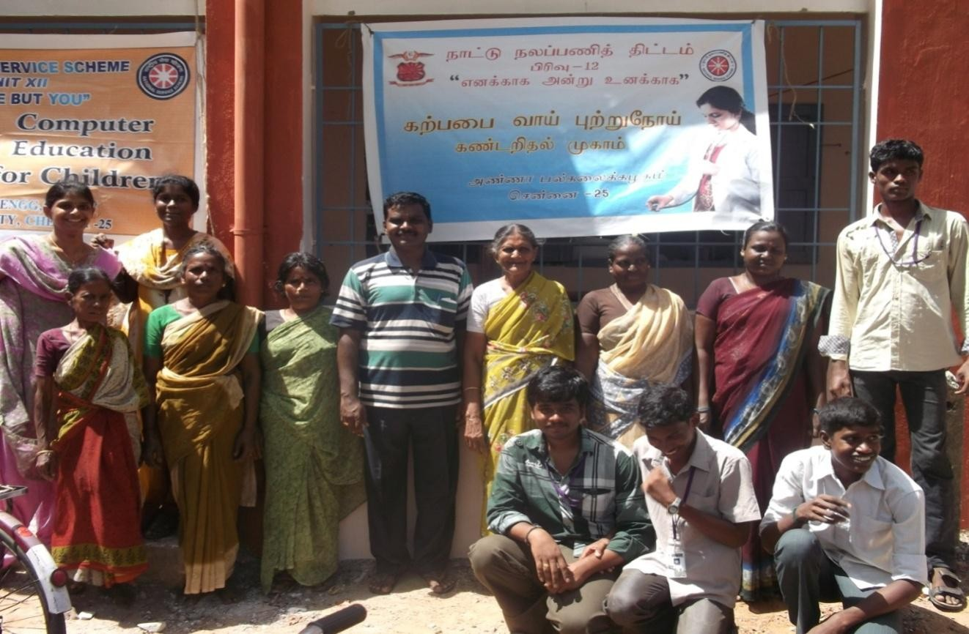

VISITED CHILDREN HOME
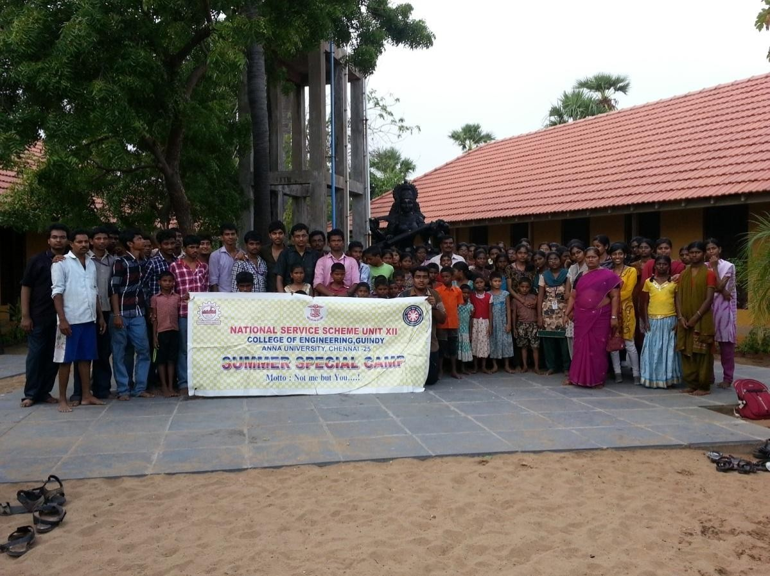

AWARENESS ON PLASTICS
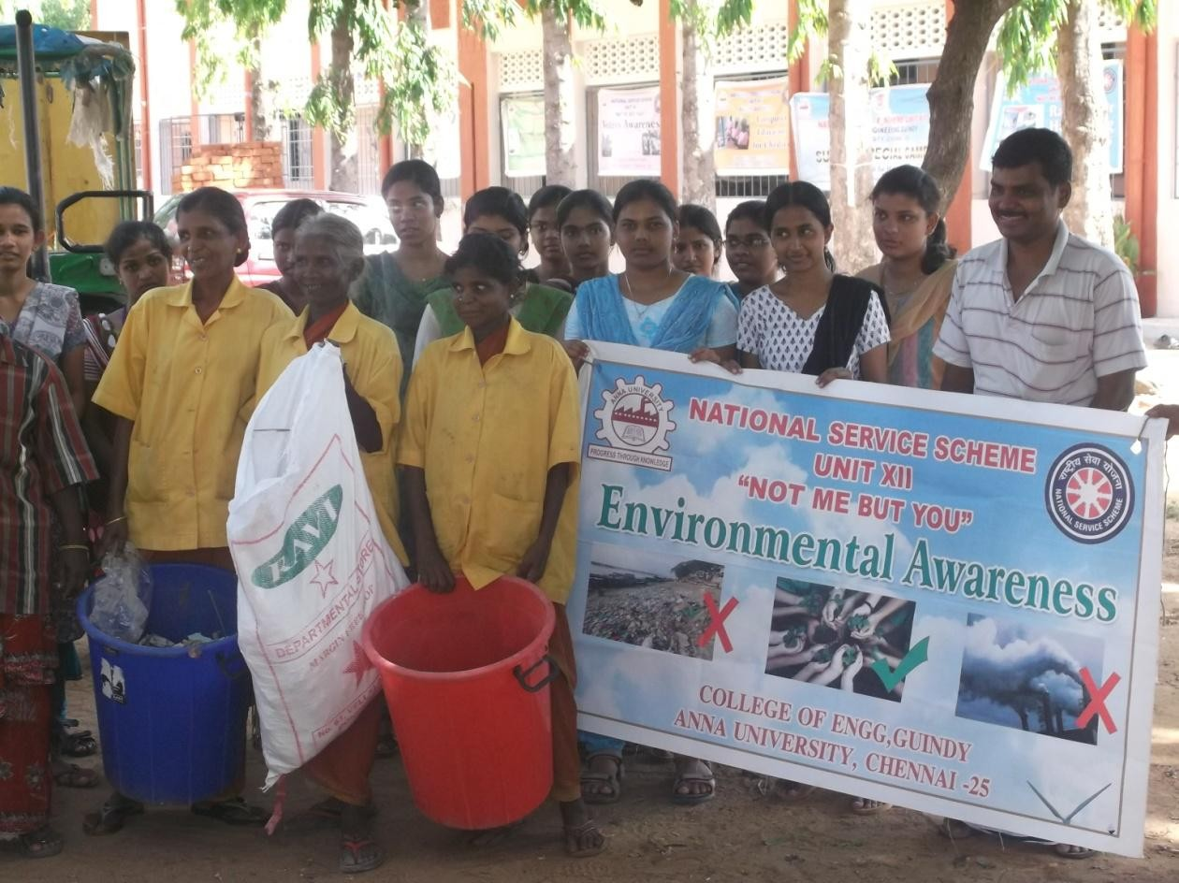
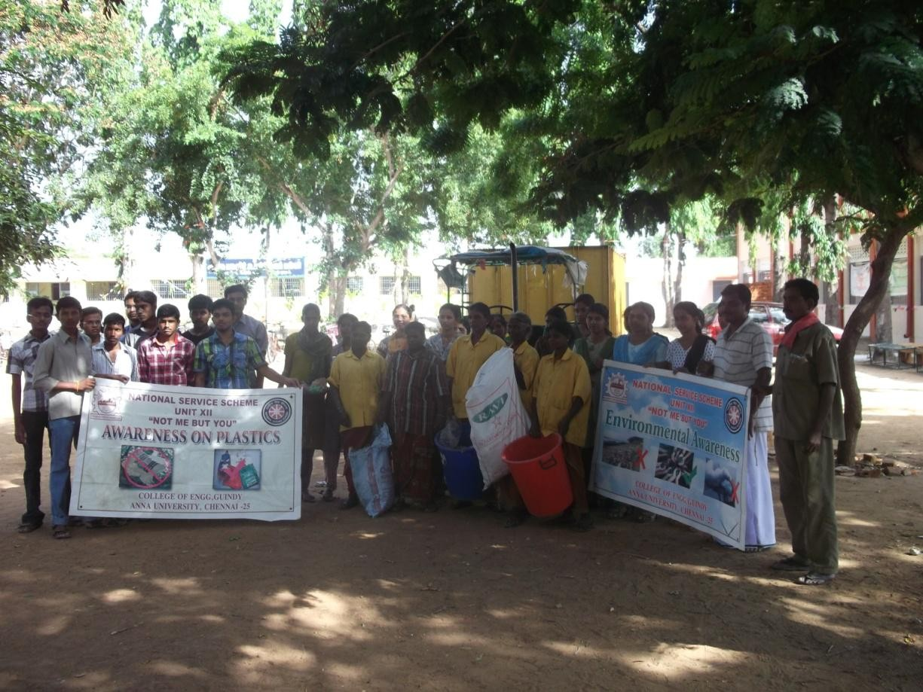

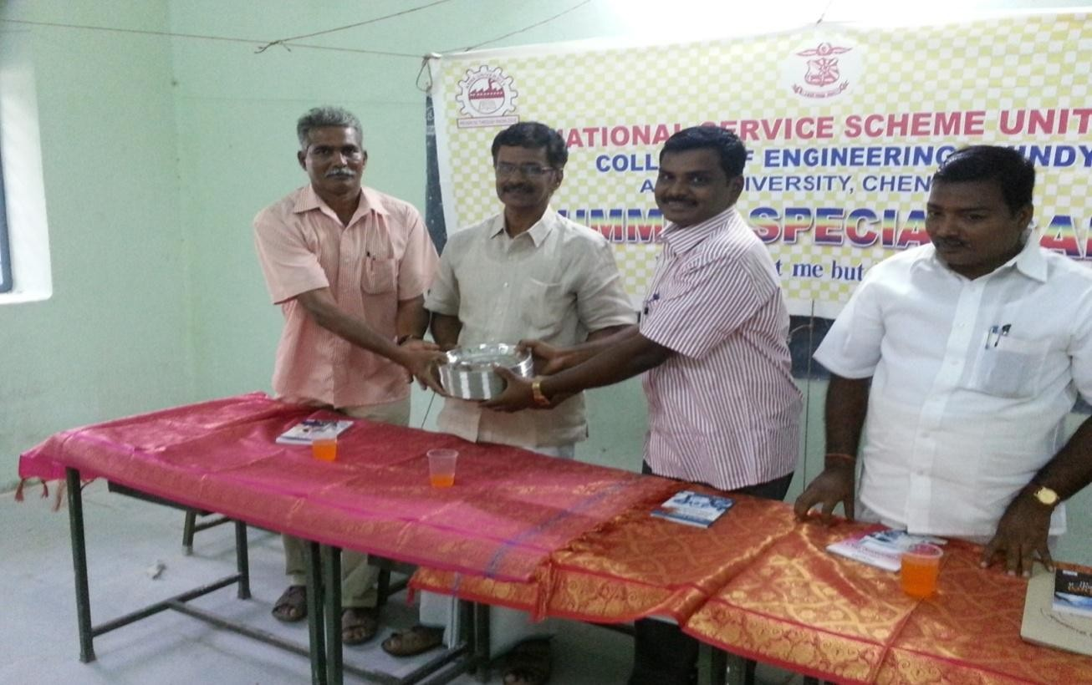
DONATED PLATED FOR GOVERNMENT SCHOOL STUDENTS
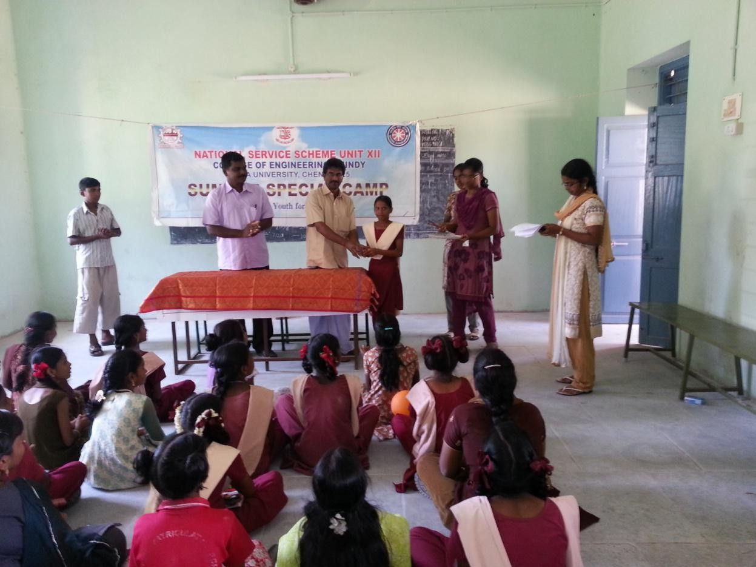

LIBRARY BOOKS DONATION

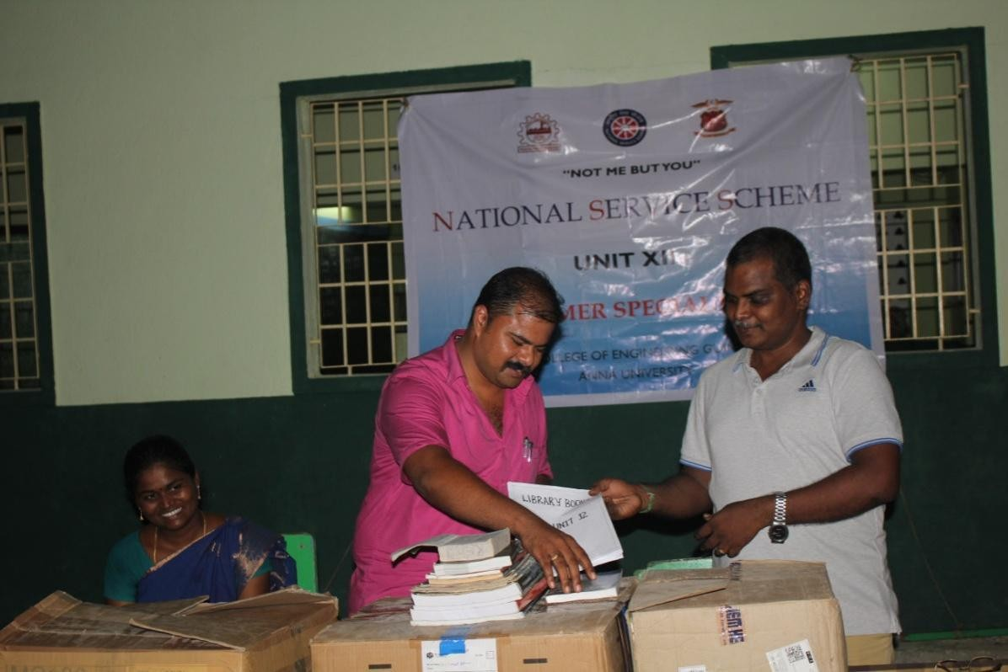
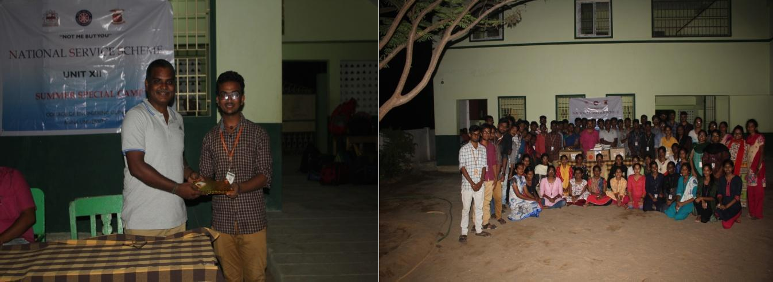

SCIENCE EXHBITION AND TREE PLANTATION
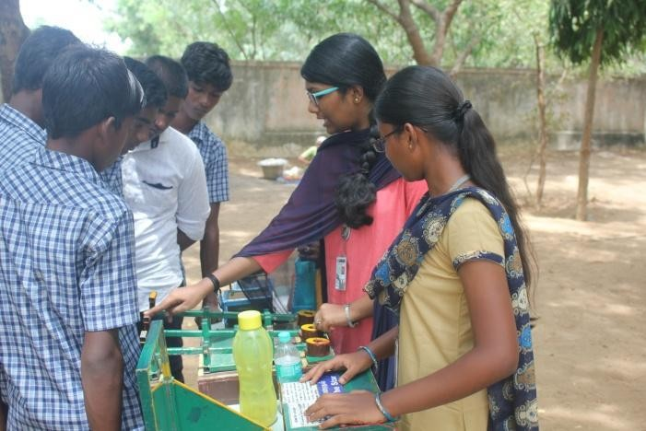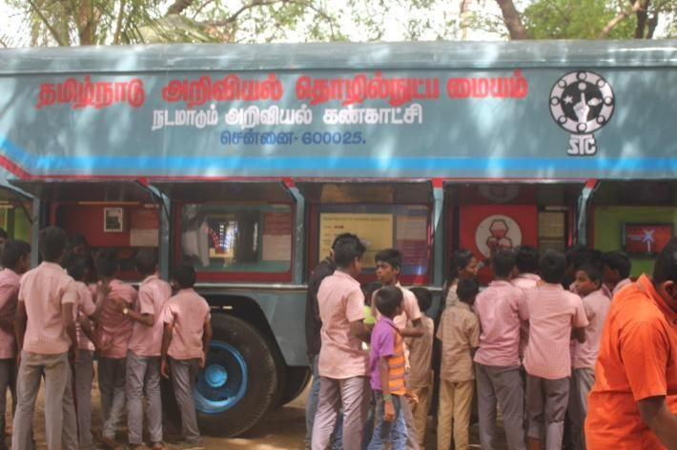
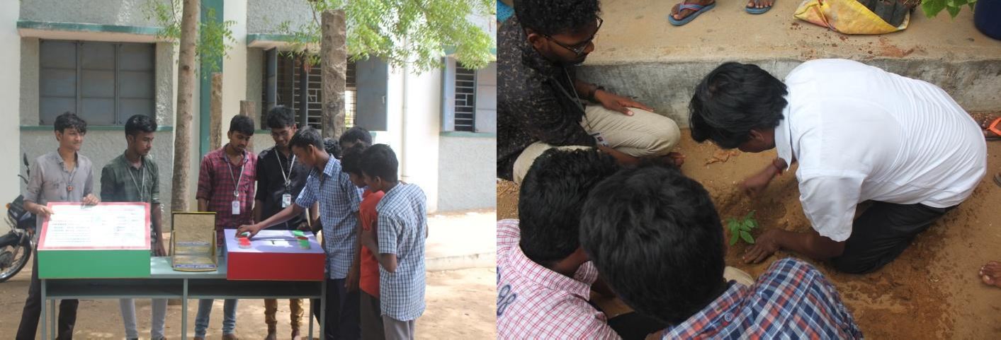
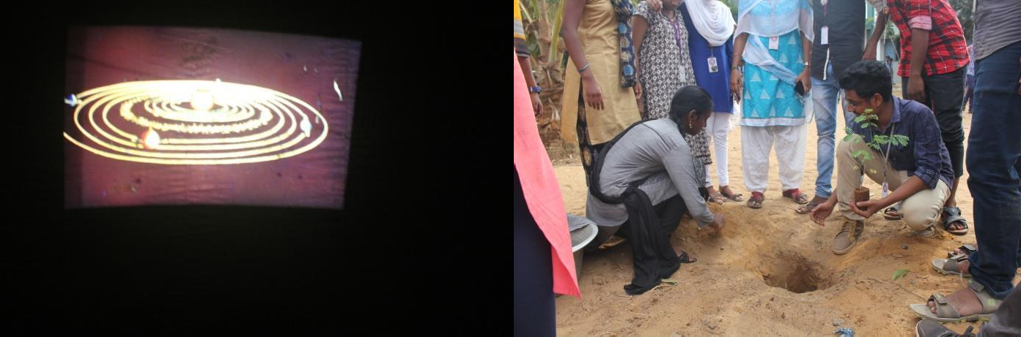

SPORTS DAY CELEBRATION AND CAREER GUIDANCE PROGRAMME
.
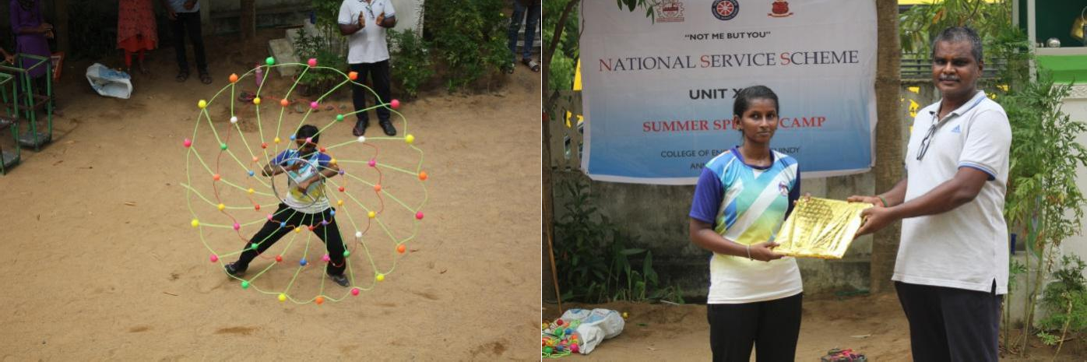
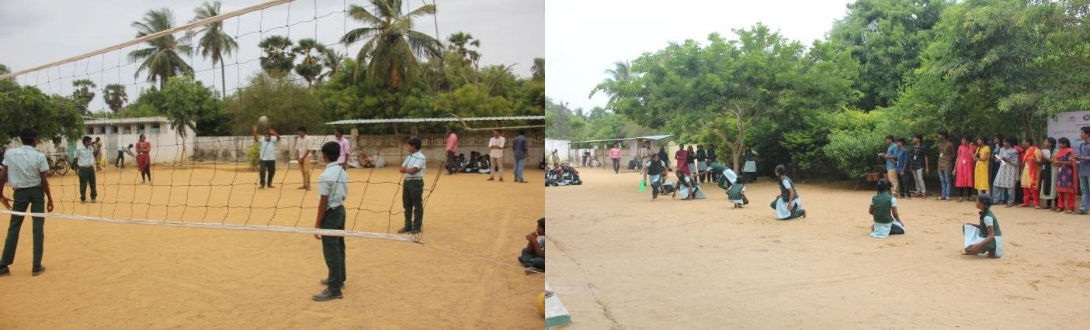

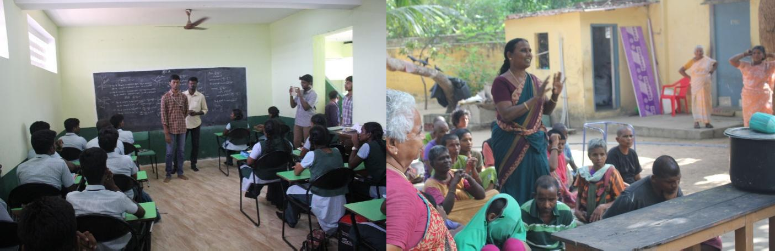
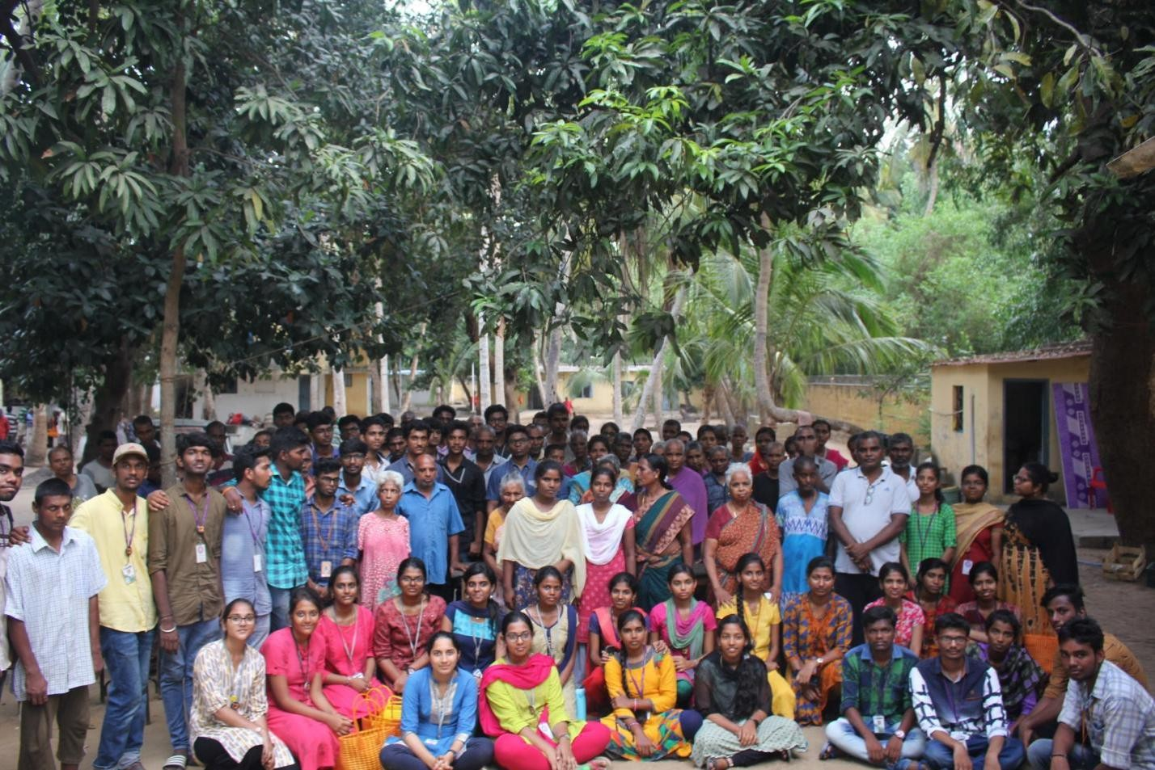

MEDICAL CAMP AND HEALTH AWARENESS RALLY

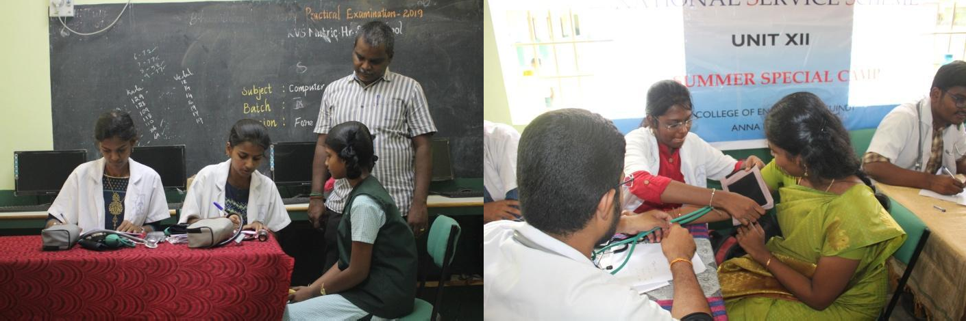
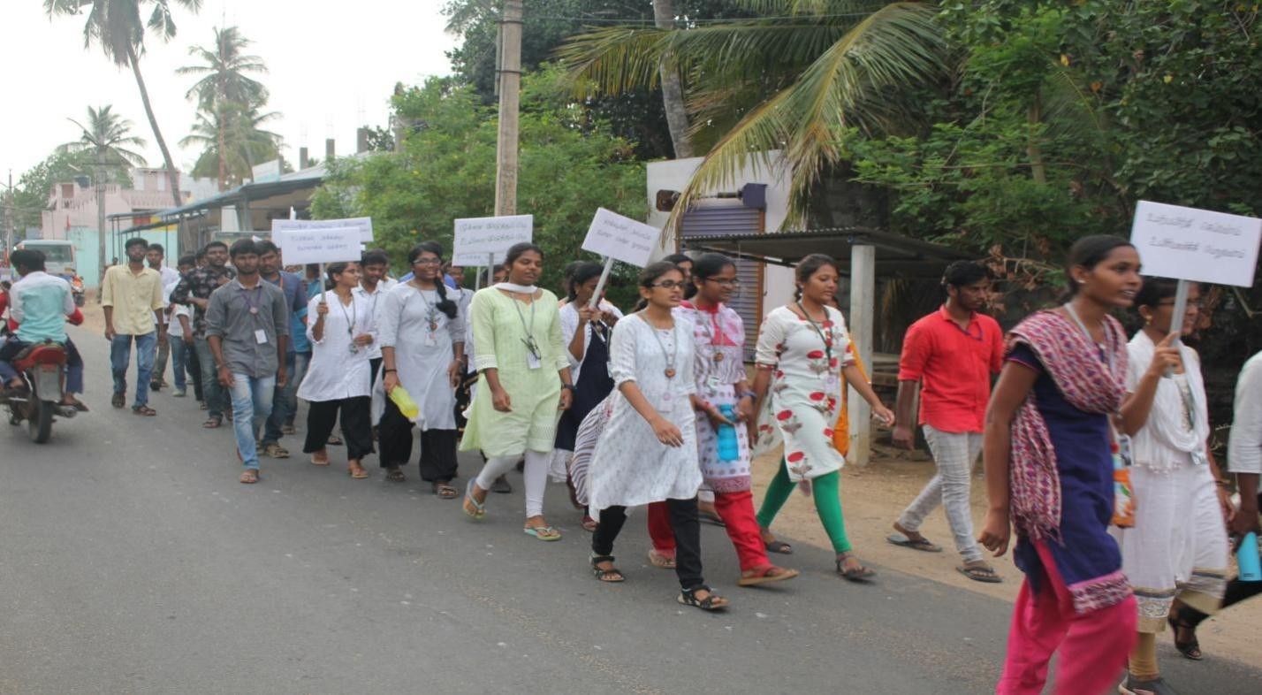

SURVEY AND STREET PLAY
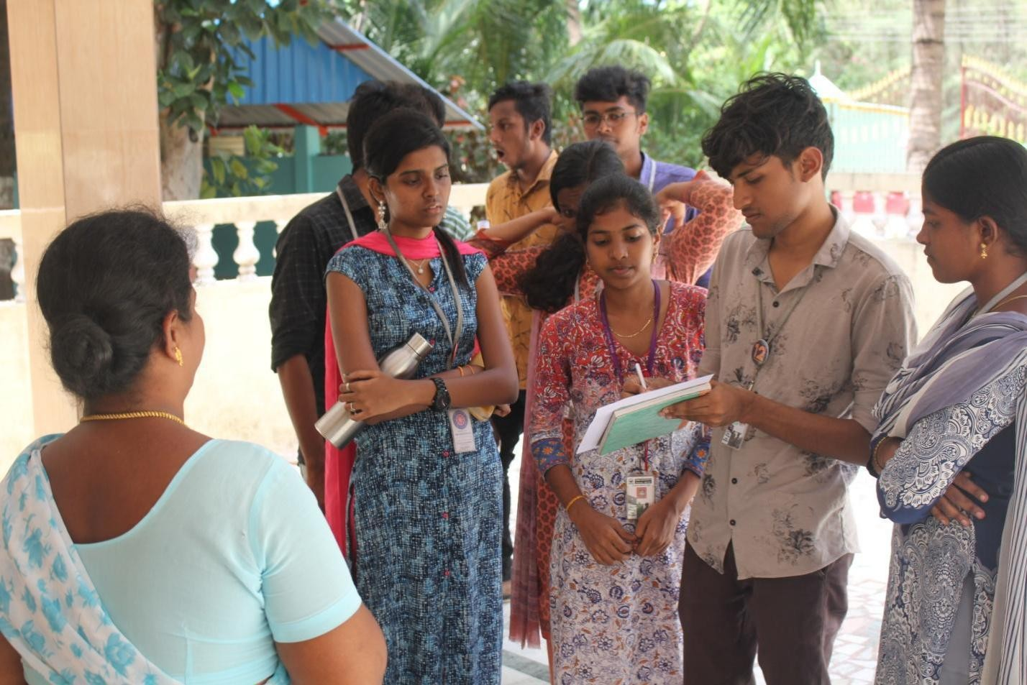
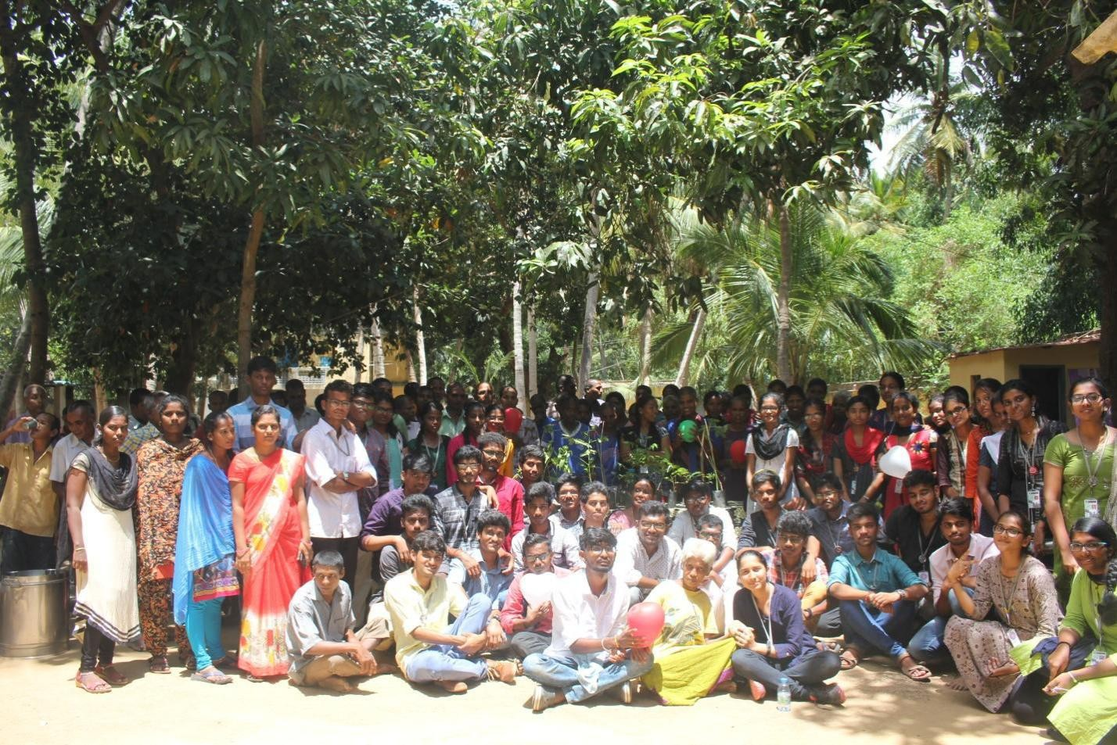

Organic Forming

