# UGC EXTENSION ACTIVITIES

# ONE DAY WORKSHOP ON “COMPUTER LITERACY” IN RURAL AREA UNDER UGC - 12th PLAN

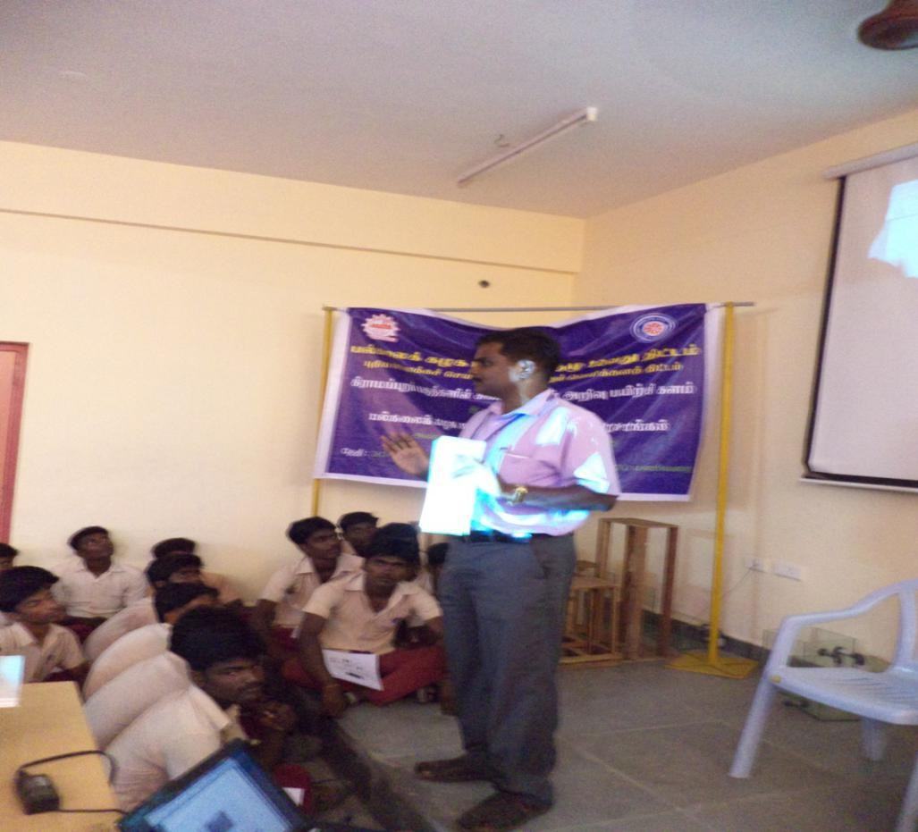

**ONE DAY WORKSHOP ON “COMPUTER LITERACY” IN RURAL AREA UNDER UGC - 12th PLAN**

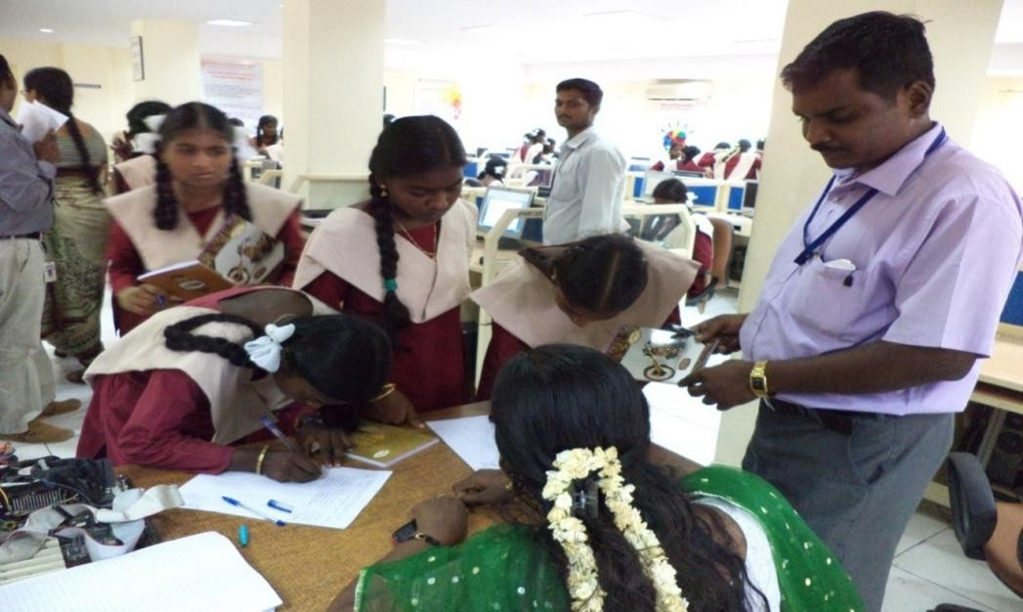

# ONE DAY WORKSHOP ON “COMPUTER LITERACY” IN RURAL AREA UNDER UGC - 12th PLAN

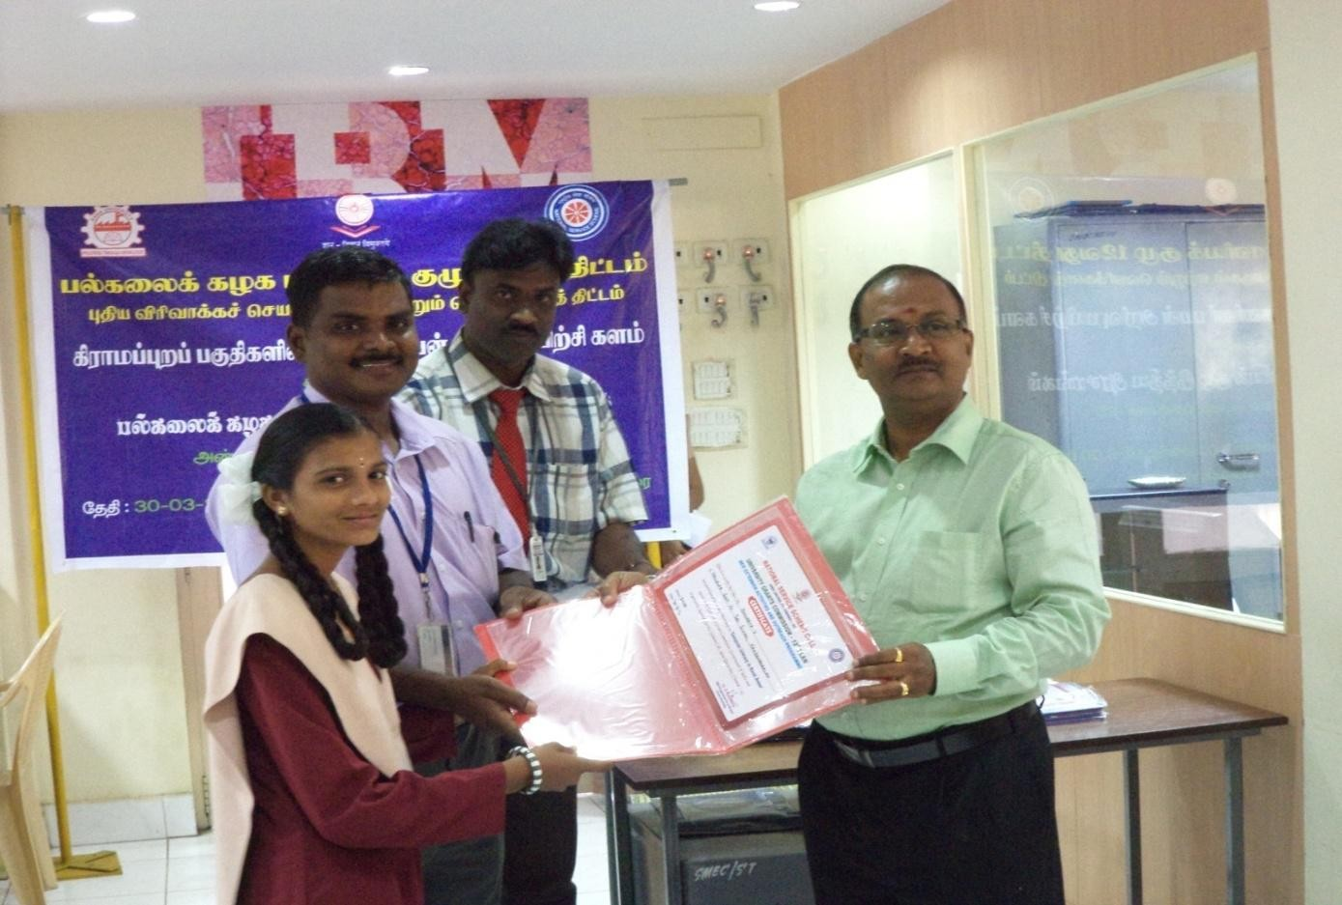

**ONE DAY WORKSHOP ON “COMPUTER LITERACY” IN RURAL AREA UNDER UGC - 12th PLAN**

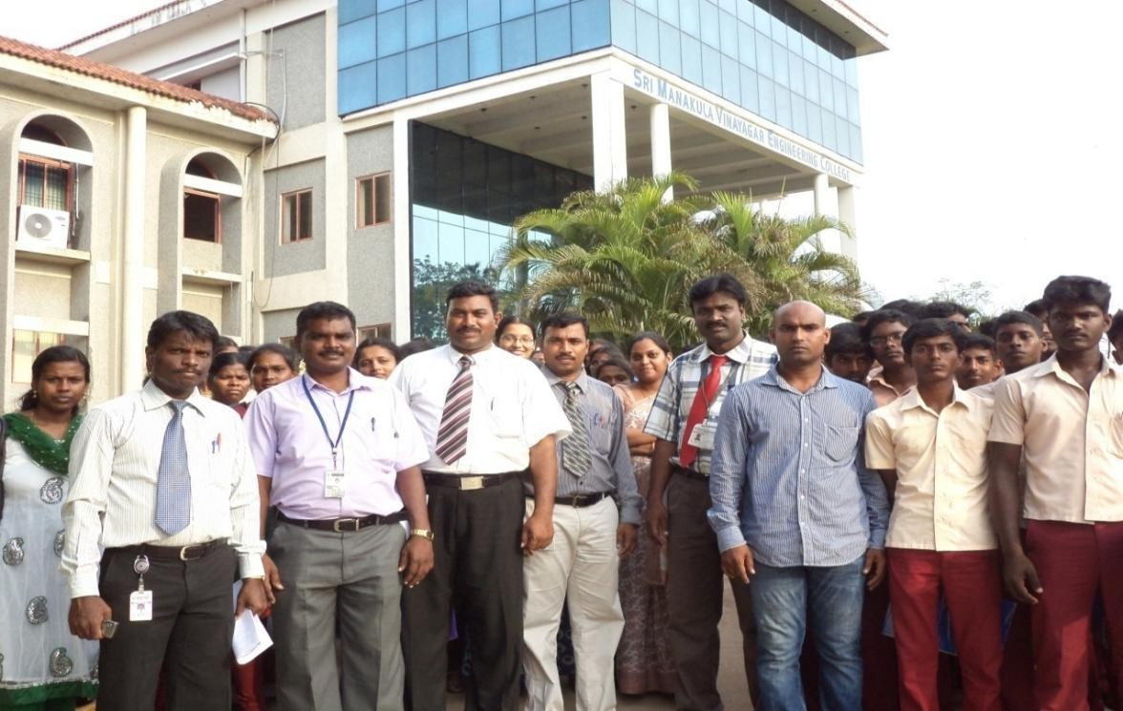

**ONE DAY WORKSHOP ON “COMPUTER LITERACY” IN RURAL AREA UNDER UGC - 12th PLAN**

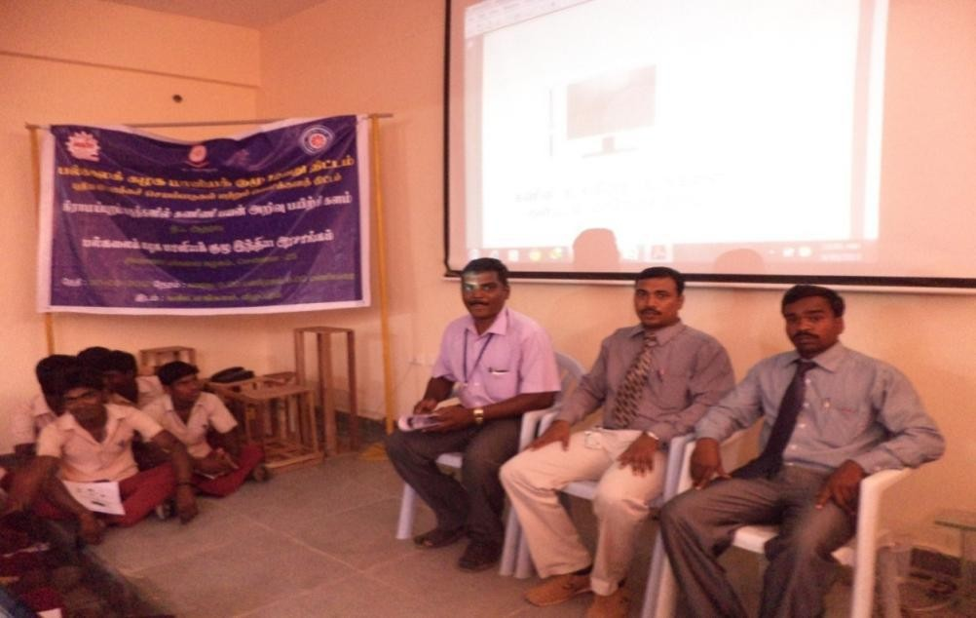

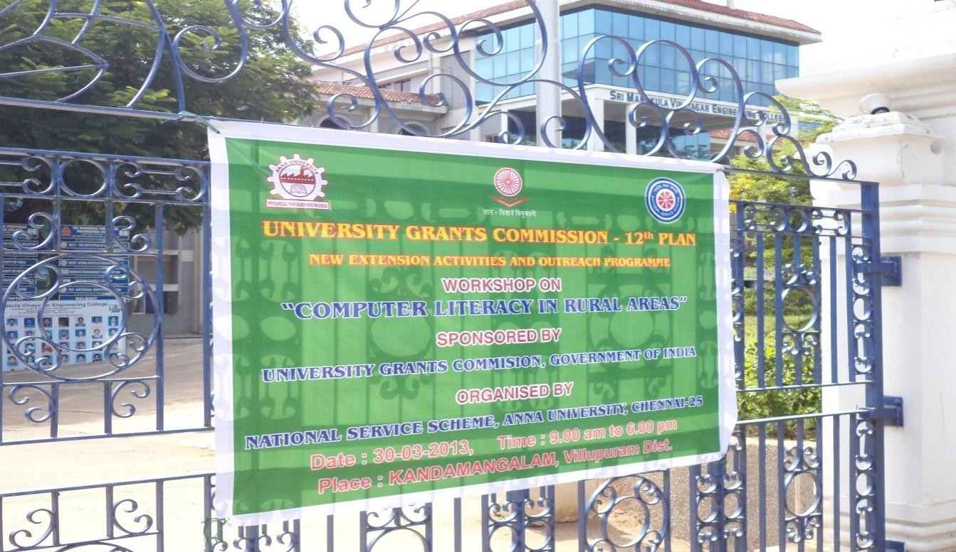

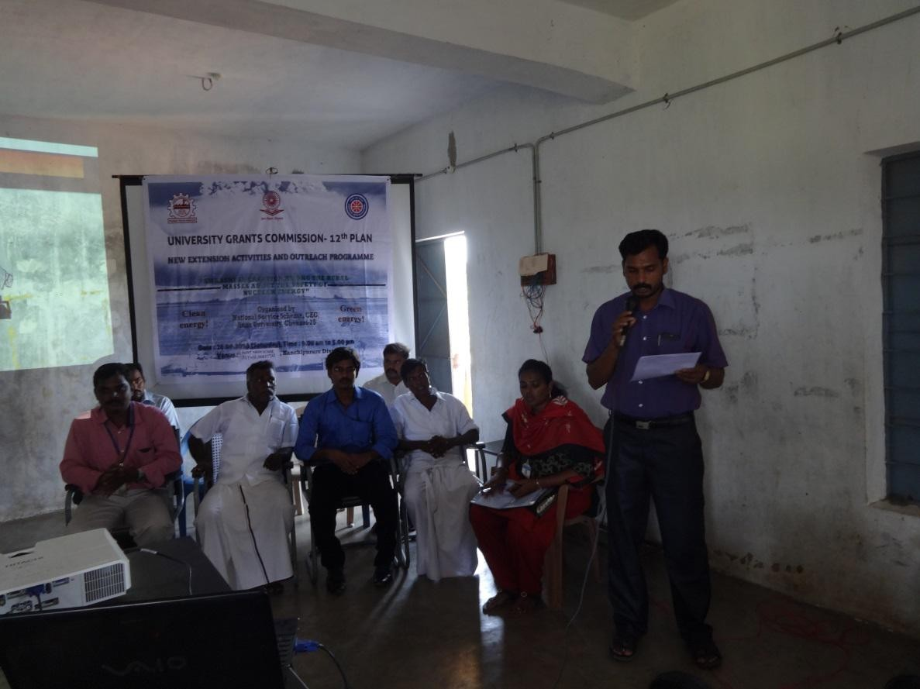**AWARENESS CREATION AMONG THE RURAL MASSES ABOUT THE SAFETY OF NUCLEAR ENERGY**